PREPARE - a programme to strengthen civil society and to promote multi-national exchange in rural development

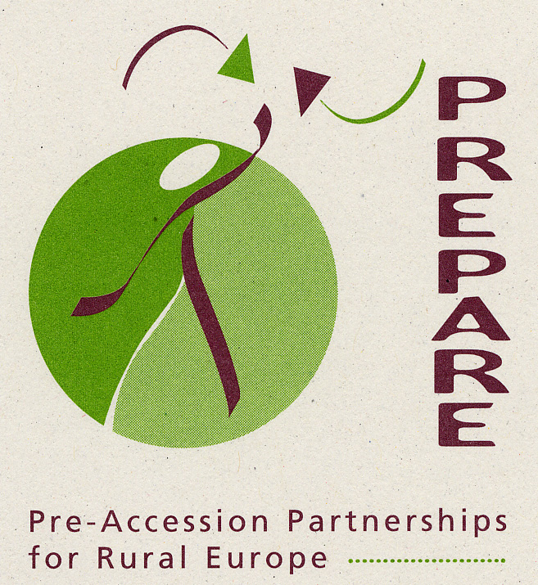 PREPARENews 2 December 2003

To members of the PREPARE Network and all friends and contacts of the PREPARE programme

Merry Christmas and a Happy New Year Tanti Auguri di buon Anno e buon Natale
Весела Коледа и Честита Нова Година (Vesela Koleda i Chestita Nova Godina)

Veselé vánoce a šťastný nový rok Priecigus Ziemassvetkus un laimigu Jauno gadu!

Prettige Kerstdagen en een Gelukkig Nieuwjaar Wesołych Świąt i Szczęśliwego Nowego Roku!
Häid Jōule ja Head Uut Aastat ! Cráciun Fericit si la Multi Ani

Hyvää Joulua ja Onnellista Uutta Vuotta ! Veselé Vianoce a stastný Nový rok!
Joyeux Noël et Bonne Année Srečen Božič ter Srečno, Zdravo in Veselo Novo Leto !
Fröhliche Weihnachten und ein gutes neues Jahr Feliz Navidad y Prospero Año Nuevo
Kellemes Karácsonyi Ūnnepeket És Boldog új Évet ! God Jul och Gott Nytt År !

We send you greetings for the festive season, after an active year for the PREPARE programme. We look forward to contact with you as this programme develops during the coming year.
Hannes Lorenzen (Forum Synergies), e-mail hlorenzen@europarl.eu.int
Michael Dower (ECOVAST), e-mail mdower@glos.ac.uk
Kaja Kaur (Kodukant, Estonia), e-mail kajakaur@hot.ee
Márta Márczis (Hungarian Rural Parliament), e-mail marta.marczis@undp.org
Jela Tvrdonova (Slovakian Rural Parliament), e-mail tvrdonova@arvi.sk
Marko Koščak (Slovenian Rural Development Network), e-mail heritage.trail@siol.net
Urszula Budzich-Szukala (Polish Forum for the Animation of Rural Areas),
e-mail ula@cofund.org.pl
Nils Lagerroth (Swedish Popular Movements Council and Swedish Federation of
Rural Economy and Agriculture Societies), e-mail nils.lagerroth@hs-o.hush.se
Peter Backa and Tarja Helanen (Finnish Village Action Association),
e-mail pb@multi.fi or tarja.helanen@kylatoiminta.fi

PREPARE Gathering, October 2003
The PREPARE Gathering, with its complex of six Travelling Workshops, was an organisational success and a remarkable family event. 95 people from 17 countries converged on the village of Pocuvadlo in the forested hills of central Slovakia. Of this total, over 70 took part in the 6 travelling Workshops, lasting two or three days, before they reached Slovakia.
- From Bulgaria came 10 participants, who travelled by air to Budapest and then joined a Travelling workshop organised by the Hungarian Rural Parliament. This included visits to the villages of Zsambek and Etyek to study how value can be added to heritage and to agricultural products; and meetings in the capital with the secretariat of the Rural Policy Council, and with the Rural Development Department in the Ministry of Agriculture.
- From the Czech Republic came a group of participants from that country and from Scotland and Poland, who visited action groups in the Czech micro-regions of Haná and Povodi Stonávky, then three rural areas –Palczowice, Lanckorona and Babia Góra – in Poland on their way to Slovakia.
- From Romania came 11 participants, who spent one day visiting three rural development projects in northern Romania, then half a day in Oradea to draw conclusions from these visits, before setting off to travel through Hungary, where they visited the micro-region Association of Borsodi and then met officials at the Ministry of Agriculture in Budapest.
- From Slovenia came 8 participants (7 Slovenian, one from England) who travelled through Hungary, visiting a regional development agency and a local action group at Vasvar, and the Association of Rural Youth at the village of Börcs near Györ.
- A larger group of people from Scotland, Finland, Estonia, Latvia and Lithuania flew into Warsaw; were joined by participants from Poland; and then split into two groups to travel by bus to Slovakia. One group passed through central Poland, visiting development associations or partnerships at Baltow and in Bochnia, a model farm at Stryszow, and the Babia Góra partnership. The other group passed through eastern Poland, visiting the Western Polesie Biosphere Reserve, the Academy for Theatre Practices at Gardzienice, and the LEADER-type partnership at Dolina Strugu.

All the groups then came together at Pocuvadlo, in a large field study centre set among woodlands. The programme was split into three days :
- A first day of introductions and of reports on the Travelling \Workshops, followed by a general discussion;
- A second day of workshops, on subjects chosen by the participants, plus an afternoon visit to the town of Banska Stiavnica which is a World Heritage site;
- A final day of presentations and discussion about the PREPARE programme and about what the participants would like to do in their own countries or more widely in Europe.

The Gathering offered a strong feeling of fellowship among people from 17 countries, in both western and central Europe. It was agreed that we should all work together to strengthen civil society throughout rural Europe. We should press governments and the European Union to take civil society seriously as a partner in rural development programmes, and to provide adequate funding for rural development in the coming years. Participants from Latvia, Lithuania, Romania and Bulgaria – countries which do not now have national rural movements – expressed determination to work towards creation of such movements, with help from PREPARE.

A full report of the Gathering will be available in January 2004; will be circulated to those who took part in the gathering; and will be placed on the PREPARE website. If you have a few good digital photographs of the gathering or the travelling workshops, please send them to Jela Tvrdonova (e-mail tvrdonova@arvi.sk) or Michael Dower (mdower@glos.ac.uk).

PREPARE Gathering 2004
Tanya Shoumkova, leader of the UNDP team in the Ministry of Agriculture in Bulgaria, who was at the Gathering in Pocuvadlo with several of her colleagues, has suggested that a PREPARE Gathering should be held in Bulgaria in September or October 2004. We welcome this idea, and have suggested that the event might be held near the border with Romania. This would allow participants to travel to either Bucharest and Sofia, and to take part in travelling workshops on their way to the venue. You will receive further news in due course.

Salzburg Conference
Most of the PREPARE Organising Group, and many others from the Network, were among the 1000 participants in the European Conference on Rural Development, called by European Commissioner Franz Fischler and held in Salzburg, Austria on 12 to 14 November. On the first evening, PREPARE hosted a meeting of about 40 participants to discuss the ideas that we might all promote during the Conference. These points are summarised in the ‘Statement from PREPARE to the Salzburg Conference’, which can be found on our Website, www.preparenetwork.org

We were able to express these ideas, both in the plenary sessions and in the workshops. However, a Conference of one and a half days did not permit full discussion, and the Conclusions were disappointingly bland. The most encouraging hint came from Commissioners Fischler (Agriculture) and Barnier (Regions), who suggested that the financial framework from 2007 onwards (now being discussed within the Commission) might include a new Rural Development Fund, separate from the CAP. Such a Fund might provide finance for rural development, wider than agriculture, to a far greater extent that can now be achieved under Pillar 2 of the CAP.

The PREPARE Organising Group met in Brussels on 12 December, and agreed a programme of advocacy, through which we hope to influence the decisions made by the EU in the forthcoming round of discussions about the programmes for the period 2007 to 2013. We will keep you updated on this through the PREPARE website.

PREPARE in Latvia
A number of people from Latvia took part in the earlier Travelling Workshops, organised by PREPARE in 1999, 2000 and 2002. In August 2003, a meeting in Riga was organised by Janis Kleins of the Ministry of Agriculture : present were about 15 people from various non-government organisations, plus two members of the PREPARE Organising Group - Kaja Kaur President of Kodukant in Estonia, and Michael Dower. This meeting set up a small working group to plan the steps towards the creation of a national rural movement. A strong Latvian team attended the PREPARE Gathering in Slovakia. Now, plans are being made for a series of regional workshops in February to March 2004, followed by a national workshop.

Application to the Mott Foundation
The activity within the PREPARE programme in 2003 was greatly assisted by a grant of USD150,000 from the C.S.Mott Foundation, which is based in Flint, Michigan, USA. We were encouraged by the Foundation to apply to them for a further grant related to 2004 and 2005. We have done this, and await their decision.

Estonia/Finland cooperation
After the PREPARE Travelling Workshop in September 2002, a transnational project was agreed between Kodukant (the Movement of Estonian Villages) and the Sepra Local Action Group in Finland. This 10-month project, which has been successfully completed, included
three study tours from Estonia to Finland, and vice versa, plus other activity. Participants in the study tours included people from Ministries, local authorities and associations and local actors, including villagers and entrepreneurs. A huge amount of information and experience was exchanged between employees and board members of the two organisations and all other participants. The local actors worked together in many workshops, and their suggestions have formed the basis for a new two-year project which has already been granted funding in Finland : the Estonian partners expect to find their share of funds from EU sources. Local actors in both of the countries are looking forward to the new project.

Transnational Cooperation
The emergence of a growing number of local action groups in the accession countries of central Europe was recognised during the Transnational Conference on Rural Development, held at Naantali, Finland in late November. This gathering of over 200 people from 15 countries included representatives of many action groups funded by the EU LEADER programme or by national programmes. The focus was on promoting multi-national cooperation between these groups. A strong plea was made that future transnational projects should include groups from central Europe. A report of the Conference will be available from the organisers, the National Network Unit of SYTY, the Finnish Village Action Association (e-mail tytti.monkkonen@kylatoiminta.fi, www.maaseutuplus.net)

Liaison with Rural NGOs

Most of the PREPARE Organising Group were among 35 people who attended a two-day European Workshop in Brussels in mid-December, organised by the French association GEYSER. The aim of this workshop was to discuss how rural and environmental NGOs can contribute to the growing European debate about rural development. PREPARE strongly welcomed this opportunity to consider calmly with other NGOs how we can together influence the EU and member governments towards a fuller understanding of the need for an integrated approach to the future of rural areas. We expect that the discussion will lead to useful cooperation between PREPARE and other networks.

Two events in July 2004
Readers of this Newsletter may like to take interest in two events which focus on the educational or training aspects of rural development.
5 to 8 July Oxford, England European Rural University
This is the sixth in the series of biennial events organised by ERU. The focus in 2004 will be on ‘Sharing Futures : Regional and Rural’. Details from www.ruralnet.org.uk/~eru/

16 to 25 July Torun, Poland Euracademy Summer Academy
This is the third in the annual series of Summer Academies organised by the Euracademy partners, whose aim is to offer mid-career training for rural development professionals. The theme in 2004 will be ‘Diversification of rural economies’. The two previous Summer Academies were held in Gotland, Sweden in 2001 on the theme of ‘Sustainable Rural Tourism’; and at Ioannina in Greece in 2002 on the theme of ‘Information Society and Rural Development’. Thematic Guides based on these two earlier events, and information on the event in July 2004, from PRISMA,
17 Empedocleous Street, 11635 Athens, Greece, e-mail s.babalikis@prismanet.gr

Also see www.euracademy.org

The PREPARE Network
The aim of the PREPARE Network, which was established in mid-2003, is to promote multi-national exchange between those who are involved (as individuals or organisations) in rural development anywhere in Europe. It is conceived as an open network of individuals, multi-polar in nature, controlled by its membership, flexible in operation. There will be no subscription, unless the members later decide that there should be. Organisations, including those on the PREPARE Organising Group, are not formal members : they are represented by individuals, on equal terms to all other members. The network is conceived as a meeting-point for people who work in the public, voluntary or private sectors : thus, people from government and from non-government organisations are equally welcome.

The main medium of the Network is the Website, www.PREPAREnetwork.org

If you are involved in rural development in any capacity, anywhere in Europe, and you share the idea that drives the PREPARE programme – to strengthen civil society and to promote multi-national exchange in rural development – we invite you to join the PREPARE Network. The accession form can be found on the PREPARE Website : please let us know if you have difficulty in accessing it.

For information on PREPARE, visit the PREPARE Website, www.PREPARENetwork.org, or contact Michael Dower, 56 Painswick Road, Cheltenham, GL50 2ER, England,
tel +44 1242 226511, e-mail mdower@glos.ac.uk
preparenews02

