
PREPARE - Partnership for Rural Europe www.preparenetwork.org

PREPARE News 10
Summer 2007

For members of the PREPARE Network and all friends of the PREPARE Programme

Dear Friends,

The release of PREPARE News 10 has been delayed because we have wanted to provide you with more precise information about the next PREPARE Gathering.

Thus, this Newsletter brings you the following:

I. Preliminary information about PREPARE Gathering 2007;
II. A review of past events (since the publication of the last Newsletter);
III. Information about progress of the PREPARE programme;
IV. Plans for future events and activities.

I. PREPARE Gathering 2007

Every year, PREPARE organises a multi-national event which brings together representatives of civil society and public sector from all the countries where PREPARE is active or has partners. We organise each Gathering in a different country and with a different theme.

In 2007, the PREPARE Gathering will be held for the first time in Poland, on the border with Ukraine, and it will be organised together with the Polish Rural Forum. The main theme of the Gathering is defined broadly as integrated rural development. The Travelling Workshops which will precede the Gathering will be an opportunity to visit projects in Poland and in Ukraine.

The Travelling Workshops will be organised on 9th and 10th of October, and the main Gathering will be held on the 11th of October in Przemysl. The participants will also have an opportunity to take part in an international conference on LEADER organised by the Polish Rural Forum within the National Leader+ Network activities (October 12 and 13, also in Przemysl).

More detailed information about programme, conditions for participation and registration will be available on the PREPARE website (www.preparenetwork.org) by the end of August.

II. A review of past events

Below, we briefly summarise events which took place since the publication of the last PREPARE Newsletter of October 2006. Attentive readers of our website will be familiar with most (although not all) of these events.

(a) LEADER in the New Member States – an international conference in Tihany (Hungary), 14-16 November 2006. This conference, organised by the European Leader+ Observatory and Contact Point in Brussels, was an opportunity to exchange experiences of LEADER and LEADER-type activities in old and new Member States. PREPARE and its national partners were involved in the preparation of the conference programme, suggested speakers and helped in the recruitment of participants.

(b) The regional LEADER conference of the Asturian Local Action Groups in Oviedo (Spain) took place in December 2006. It was an opportunity for the Asturian LAGs to discuss their preparation for the new programming period 2007-2013 and the Leader Axis. To strengthen the good contact PREPARE has had with the Spanish LEADER groups, the Coordinator of PREPARE was invited to take part in the seminar and to present the experience of the new EU member states with LEADER-type actions. Representatives of ELARD (the European LEADER Association for Rural Development) were also present.

(c) The Second Congress of the Lithuanian Rural Communities’ Union in Kaunas, 16 March 2007. The bi-annual meeting of the Lithuanian partner organisation in PREPARE gathered nearly 300 representatives of rural communities from all over the country. The guest speakers included Ms Kazimiera Prunskiene, Minister of Agriculture, Mr Viktoras Rinkievicius, Head of the parliamentary Agricultural Committee, Mr Bronius Markauskas, President of the Chamber of Agriculture, as well as the PREPARE Coordinator (Urszula Budzich-Szukala).

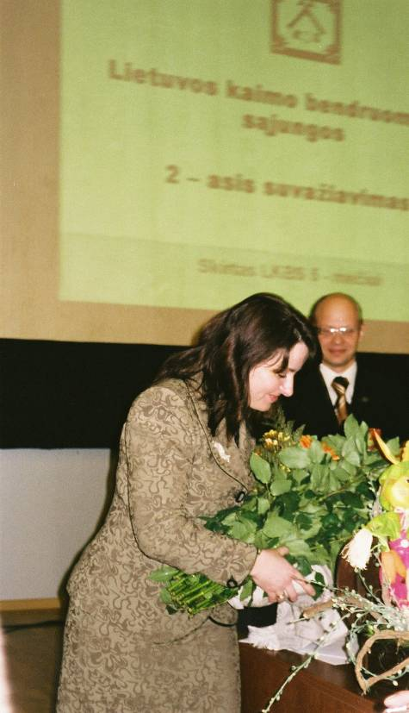

The authorities of the Union were re-elected for another term of office, including Guoda Burokiene, the Lithuanian representative on the PREPARE Organising Group, who was again (and with considerable applause) elected as Chairperson of the Lithuanian Rural Communities Union.

(d) Another large-scale event focusing on LEADER in the EU was the seminar on “The legacy of LEADER on the local level” held in Corsica from 24 to 26 April 2007. This was the seventh seminar organised by the European Leader+ Observatory and Contact Point. Its aim was to present the experience gained in the course of implementation of LEADER related to the territorial approach, functioning of the partnership, developing and implementing local strategies, as well as LAG cooperation and networking. Almost 300 people from all over Europe took part in this event.

Several sessions were focused on networking. In one of them the experiences in the new EU member states of formal and informal networks (including PREPARE and its partners) were discussed. Valdis Kudins from Latvia (member of the PREPARE Organising Group) presented the activities of the Latvian Rural Forum which plays the role of the national LAG network, carries out training and capacity building for the LAGs.

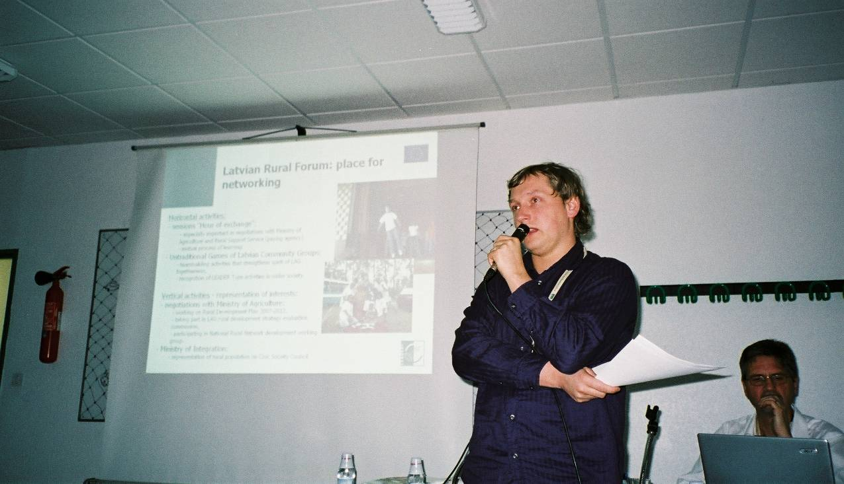

The participants had the opportunity to see projects carried out by several Corsican LAGs and taste local products. One of the study groups found its way blocked by.... the Corsican farmers with their tractors! It turned out that these farmers had learnt that a European event focused on rural areas was held in the neighbourhood and they quickly got organised, looking for a chance to explain their position to the EU officials present. They were invited by the conference organisers to come to the final session of the seminar.

(e) Since the last Newsletter there have been two meetings of the Commission’s Advisory Group on Rural Development on which PREPARE has a seat: on December 18, 2006 and on May 11, 2007. The latter meeting included i.a. the following issues:

- a presentation of the state-of-play of Rural Development Programmes (RDPs) – most of them had been submitted by the time of the meeting, but only a few finally approved; the discussion at the Advisory Group focused mainly on the concern of the farmers’ organisations about the potential delays in starting the programmes and also the fact that farmers might get less funding than in the previous period; the Commission’s representatives could not at this stage explain how the Leader Axis was used in relation to the remaining three Axes; compared to EU regional development programmes which have all been adopted by now, the rural development programmes will in many cases only be approved by the Commission towards the end of this year. This might cause losses in funds available for 2007.

- renewable energy and its potential advantages to rural areas (e.g. slower decline in agricultural employment and agricultural land use); issues such as food vs. fuel competition for land use and sustainability were brought up in the discussion; the rapid development of plant fuel production and imports from developing countries have recently become a very hot issue in the public debate in Brussels;

- the Commission’s plans for the European Rural Development Network, shortly to be tendered for; the issues of the Coordinating Committee, Expert Committee and their relation to the Advisory Group and to the existing networks (including PREPARE and the Leader networks) were raised, but no final decisions seem to have been taken.

(this report from the Advisory Group summarises a note made by Phil Turner from ECOVAST, member of the PREPARE Organising Group)

(f) In Prague, in June 2007, there was a TAIEX seminar (workshop) on LEADER in the New Member States. According to the Commission’s standard practice, only representatives of the Managing Authorities and Paying Agencies from all the NMS were invited to this event. However, the Czech Ministry of Agriculture – who was the co-organiser, together with the TAIEX service of the European Commission – decided to invite also representatives of the civil society and Local Action Groups of the Czech Republic, including the PREPARE Czech partner – the Czech National Rural Observatory, and the newly formed LAG network supported by the Observatory.

Keynote speakers at this event included Jean-Michel Courades from DG Agri and Elena Saraceno, expert of the European Commission. Jean-Michel Courades described the current stage of programming of the Leader Axis in the Rural Development Programmes 2007-2013 and the plans for the national and European rural networks. He stressed the autonomy of LAGs in the selection of projects (also outside the measures selected by national authorities for the other three axes of RDP), and made it clear that demarcation with other funds is not applicable to the Leader Axis due to the difference in the financing mechanism. Elena Saraceno made a strong plea for Leader to remain flexible in the new period and for LAGs not to be overburdened with bureaucracy.

PREPARE was invited to the Prague workshop through its Coordinator, Urszula Budzich-Szukala, who made a presentation of the networking experience in the New Member States. To some participants, the existence of informal, bottom-up networks in many Central and Eastern European countries was a new and surprising development. Jela Tvrdonova from the Slovakian Rural Parliament and PREPARE, who was also present at the workshop, evoked a very positive reaction to her proposal to establish stronger cooperation between LAGs in the neighbouring CEE countries.

(g) News from ERA and ELARD

ERA – the European Rural Alliance, of which some PREPARE partners are founding members, was formally registered in December 2006 according to the Finnish law. The first General Assembly of ERA members will be held in Bratislava in the end of September 2007.

ELARD – the European LEADER Association for Rural Development – brings together about 600 LAGs from 11 countries. ELARD has a rotating presidency. Since July 1 the president of ELARD is from the Greek LEADER Network; it is to be remembered that in July 2006, this Network invited PREPARE to take part in its national meeting in Porto Carras. We wish good luck to our Greek colleagues, and we thank Jack Roche and the whole Irish network, who have presided ELARD for the last two years, for excellent cooperation and for their good will towards PREPARE and its partners.

III. Progress of the PREPARE Programme

(a) The future shape of PREPARE and capacity building

In March, during a meeting of the PREPARE Organising Group, a discussion was held concerning the future activities of PREPARE. The following topics were dealt with:

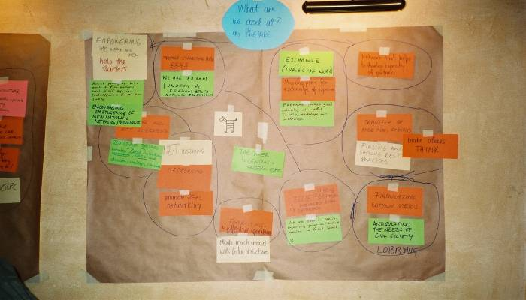
- a brainstorm on PREPARE’s strengths and weaknesses,

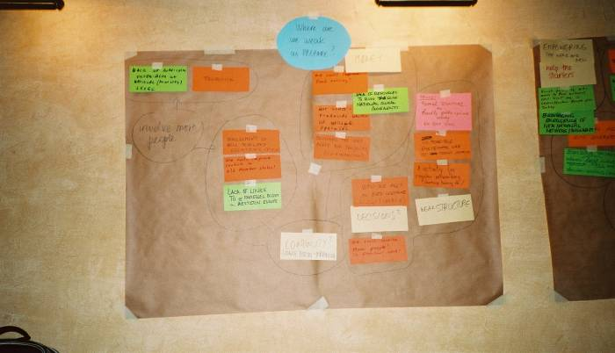
- an analysis of other existing networks with goals similar to PREPARE and of our relationships with them (it was agreed i.a. that certain PREPARE activities could be undertaken in the formula of a “working group” within ERA – in this way PREPARE will be able, for instance, to benefit from ERA’s legal entity at the European level for fundraising etc. It should be noted that the recently formed European Network for Endogenous Development also decided to operate as a working group of ERA);

- internal capacity building for the PREPARE partners. A detailed questionnaire was developed to find out the needs and expectations of the PREPARE partner organisations concerning capacity building (training, advice, financial support).

We encourage all the PREPARE network members and friends to take part in the discussion by sending us their comments concerning the role of PREPARE for European rural areas, its relation to other networks and capacity building needs. An abbreviated version of the capacity building questionnaire is available at the PREPARE website at
http://www.preparenetwork.org/web/Repositories/Documents/differ/capacity_building_for_prepare_partners_I_questionnaire_07_07_2.doc

After filling the questionnaire, please save it and send to ula@preparenetwork.org

(b) CURE for Sustainability
The PREPARE partners are working with a number of other bodies to promote a coming together of urban and rural interests, through a proposed Convention for Urban and Rural Europe (CURE). The aim of the Convention is to offer – at the time of the Mid-Term Reviews of EU programmes in 2008-9 – recommendations on policy frameworks and measures which will assist a sustainable approach to the future of urban and rural areas in Europe, achieved through effective partnership between governments and civil society.

The promoting group of bodies share a strong concern about the polarising of urban and rural interests in the mind-set of the general public and of politicians in many parts of Europe. They believe that this polarity is disguising the essential inter-dependence between cities and rural regions, and could seriously jeopardise existing efforts of the EU and member states to secure the sustainable development of regions throughout the European Union.

The Convention will bring together rural and urban stakeholders, through a series of thematic conferences based in different European regions, which will focus on how European and national programmes can be used to maximise the mutual benefit of urban and rural areas in a truly sustainable way. It is expected that the process will reach a climax at a Convention gathering by the end of 2008, during the French Council presidency. This gathering will state a vision for a sustainable future for urban and rural areas in Europe; make proposals for changes in policy within the Mid-Term Review of EU programmes; and publish ‘good practice’ examples of action contributing to a sustainable future for urban and rural areas.

In a first preparatory meeting with interested partners in Strasbourg on 9/10 July, based on the first CURE outline a draft programme for CURE was elaborated. Apart from PREPARE and ECOVAST, the RURALINNOVA network, managed by the region of Limousin, ICLEI - Local Governments for Sustainability and the CONGRESS of local and regional authorities of the Council of Europe participated. In a meeting with Commissioner Huebner, responsible for the EU regional policies the main goals and expectations of the CURE initiative were presented. The Commissioner expressed interest in the initiative. Apart from PREPARE partners, ELARD, the cities of Amsterdam and Munich as well as FAPA in Poland and the ministry for rural development in Romania have expressed strong interest so far. The next preparatory meeting is scheduled for early September in Strasbourg or Brussels. Information from Hannes Lorenzen, e-mail hansmartin.lorenzen@europarl.europa.eu

(c) Strengthening civil society in the Balkans

In the first five years of our work, a major emphasis in PREPARE’s activity was focused on support for the strengthening of civil society in the rural areas of the ten central European countries which were moving towards membership of the European Union. Two of these, Estonia and Hungary, already had national rural movements – Kodukant and the Hungarian Rural Parliament – when the PREPARE Partnership was set up in 2000. In six others – Poland, Slovakia, Lithuania, Slovenia, Latvia and the Czech Republic - national rural networks or forums have been created since then, with our support or active help. In the other two countries – Romania and Bulgaria – networks of rural NGOs are becoming stronger.

A year ago PREPARE therefore decided, with support from its main funder the Mott Foundation, to expand the geographic focus of its work to embrace those countries which may be seen as the ‘new neighbour states’ of the expanded European Union. They included five Balkan countries – Croatia, Serbia-Montenegro-Kosovo, Bosnia and Herzegovina, Albania, and Macedonia – which were at varying stages of negotiation with the European union on Stabilisation and Association Agreements; and also the Kaliningrad region of Russia, Belarus, Ukraine and Turkey. We were aware of the growing interest in rural development, and in strengthening of civil society, in many of these countries.

This interest in rural development and civil society is expressed more by NGOs than by some governments. Moreover, the political climate in some of these countries is not wholly favourable to any initiative to strengthen civil society. However, we have been fortunate in having close contact with a programme run by UNDP over the period 2002 to 2004, under the title Localizing Sustainable Development. In this programme, selected municipalities in each of these seven countries, plus Croatia, were assisted with training and outside expertise to prepare local strategies for sustainable development and to launch projects with a strong civil-society component. This programme was managed, from the UNDP office in Bratislava, by Márta Márczis, who was also President of the Hungarian Rural Parliament and a member of the PREPARE Organising Group.
Several other members of the Organising Group acted as expert advisers in different parts of this programme. This has given us a collective insight into conditions in these countries, and the potential for action to strengthen civil society there. Over the last two years, people from all these countries have taken part in PREPARE Gatherings and other events within our partnership, and have expressed their desire to act in their countries to strengthen civil society with PREPARE support. During the same period, we have begun to give direct support to initiatives to strengthen civil society in these countries, with a focus mainly on the Balkans. The first such initiative led to the formal creation, last year, of the Croatian Rural Development Network, and the hosting by that Network of a two-day national conference on rural development, the first event of that kind organised by NGOs in Croatia. More recently, we have been able to offer support to initiatives in Serbia and in Albania.

In Serbia, at the initiative of several rural NGOs led by the Educational Centre in Leskovac, a national network is in the process of being created. Several meetings of the initiative group have taken place (including one with PREPARE representatives, Jela Tvrdonova and Urszula Budzich-Szukala), and contacts have been established with the Ministry of Agriculture, UNDP and other public bodies. The launch of the national movement is planned for autumn 2007.

In Albania, some rural NGOs led by a womens’ organisation from Lim have requested the assistance of the Hungarian Rural Parliament to carry out training and capacity building. PREPARE agreed to support the Hungarian initiative in the hope that it would ultimately lead to the establishment of a national network of rural organisations in Albania. The training took place in June 2007.

Initial contacts have been established also in Macedonia – during the April visit of the PREPARE representative in Skopje, contacts have been established with several Macedonian NGOs as well as with the public sector, including the IPARD technical coordination unit and the Ministry of Local Self-government. An offer of cooperation has also been received from the Standing Working Group on Rural Development – an informal network of rural development officials from the whole South-Eastern Europe.

(d) Activities outside the PREPARE programme, but contributing to our aims
Two members of the PREPARE Organising Group, Hannes Lorenzen and Michael Dower, have been advising the Ministry of Agriculture, Forestry and Rural Development in Romania on the shaping of the rural development programme in that country. Romania joined the European Union in January this year. The new rural development programme, which was submitted formally at the end of June to the European Commission for approval, is the first comprehensive attempt to address the development needs of the ten million people who live in the rural areas.

There is widespread need to diversify the rural economy, to improve rural services and rural housing, and to protect the added value to the remarkable cultural and natural heritage of the country. A particular challenge is to meet the needs of millions of small farms, many of them at subsistence or semi-subsistence level. The sheer scale of these needs has prompted the European Union to allocate to Romania over 8 billion euros within the European Agricultural Fund for Rural Development, to be spent over the 7-year period to 2013. The Government knows that the effective use of this massive fund will depend upon mobilising the interest and the action of all rural stakeholders.Our contribution, as advisers, has focused upon this issue of mobilising the stakeholders, through the format of the National Rural Development Network which will be set up as part of the Rural Development Programme.
Information from Michael Dower, e-mail mdower@waitrose.com

IV. Future events and activities

Information has been sent to PREPARE about the following events scheduled for the second half of 2007:

(a) the Swedish transnational LEADER network meeting (July 2007)

This is an international cooperation event, with particular focus on the Baltic Sea countries, which is organised by the Swedish National Leader+ Network Unit in Visby on the island of Gotland, on July 11 and 12, 2007. Presentations of the benefit of transnational cooperation and panels on specific issues (such as the use of Leader in Axis 2, water management and Baltic Sea cooperation) are envisaged, as well as a field visit.

(b) the Estonian Rural Parliament (August 2007)

Our Estonian partner, Kodukant, organises its bi-annual event on August 17-19 in Kuremaa, with a focus on the theme “Enterprising Estonian Village in the European Union”. The main aims are: to evaluate the achievements of the Estonian rural people and Kodukant, to discuss development needs for the next period and to make suggestions to decision-makers concerning rural development policies. International participants are also invited.

(c) the Sixth Summer Academy (August 2007)

This event, organised by the Euracademy Association in Chania on the Island of Crete (Greece), is focused on the role of culture in sustainable rural development. It will be held between 17 and 24 of August 2007.

(d) the Finnish LEADER seminar (September 2007)

The international LEADER seminar will be organised by our Finnish partner SYTY in Joensuu on September 4-7, 2007. Its theme will be how to use experiences from the old to build the new Leader. Sessions on evaluation, cooperation between researchers and developers, as well as practical workshops on methods and tools are also envisaged. The working language will be English.

(e) a conference on rural policies for 2013 and beyond (September 2007)

The conference “Future policies for rural Europe – 2013 and beyond. Delivering sustainable rural land management in a changing Europe”, organised by the UK’s Land Use Policy Group and the German Federal Agency for Nature Conservation, will be held in Brussels on September 19 and 20, 2007.

(f) the international LEADER conference and travelling workshop in Poland (October 2007)

This event is organised by the Polish Rural Forum within the framework of the National Leader+ Network. It will be held in the town of Przemysl in South-Eastern Poland on October 12 and 13, and it will be preceded by travelling workshops in Poland and Ukraine and by the PREPARE Gathering. Representatives of LAGs and rural networks from all EU member states and candidate countries, as well as Ukraine, are invited.

(g) final conference of LEADER+ in Europe (November 2007)

The final conference, summing up the experience of LEADER+ in the EU, is planned by the European Observatory and Contact Point to be organised in Portugal in the second half of November 2007. The exact date and place are going to be announced shortly.

(h) UNDP conference on rural poverty (October 2007)

An international conference on "Cross-border cooperation for the elimination of rural poverty" will be organised by UNDP (which has on many occasions supported various PREPARE's activities) in the Cserehat region of Hungary. The participants will get acquainted with the specific character of poverty in border regions and with projects managed by UNDP in Hungary and Slovakia. The conference will take place from 23 to 25 of October.

More information about the above-mentioned events is to be found on the PREPARE website, www.preparenetwork.org

PREPARE Coordinator
Urszula Budzich-Szukala
ul. Ciszewskiego 8
00-786 Warszawa, Poland

phone: +48 602 745 058, +48 22 593 16 45
e-mail: ula@preparenetwork.org, ula@cofund.org.pl

