
PREPARE - Partnership for Rural Europe www.preparenetwork.org

PREPARE News 11
Winter 2007

For members of the PREPARE Network and all friends of the PREPARE Programme

Dear PREPARE Friends,

Merry Christmas and a Happy New Year!
Tanti Auguri di buon Anno e buon Natale
Весела Коледа и Честита Нова Година
(Vesela Koleda i Chestita Nova Godina)

Veselé vánoce a šťastný nový rok

Priecigus Ziemassvetkus un laimigu Jauno gadu!

Prettige Kerstdagen en een Gelukkig Nieuwjaar

Wesołych Świąt i Szczęśliwego Nowego Roku!
Häid Jōule ja Head Uut Aastat !
Cráciun Fericit si la Multi Ani

Hyvää Joulua ja Onnellista Uutta Vuotta !

Veselé Vianoce a stastný Nový rok!
Joyeux Noël et Bonne Année
Srečen Božič ter Srečno, Zdravo in Veselo Novo Leto !
Fröhliche Weihnachten und ein gutes neues Jahr Feliz Navidad y Prospero Año Nuevo
Kellemes Karácsonyi Ūnnepeket És Boldog új Évet ! God Jul och Gott Nytt År !
ΚΑΛΑ ΧΡΙΣΤΟΥΓΕΝΝΑ ΚΙ ΕΥΤΙΧΙΣΜΕΝΟΣ Ο ΝΕΟΣ ΧΡΟΝΟΣ (Kala Hristougenna ki Eutihismenos o Neos Hronos)
Geru Sventu Kaledu ir laimingu Naujuju Metu!

This Newsletter brings you information on:

(1) the PREPARE Annual Gathering 2007 (Przemysl, Poland, 9-11 October) and the preceding Travelling Workshops in Poland and Ukraine;
(2) PREPARE Scholarships;
(3) PREPARE in Belarus;
(4) CURE for sustainability;
(5) the meeting of the Rural Development Advisory Group (Brussels, 4 December) and the Commission’s proposals concerning the creation of the European Rural Development Networks;
(6) update on recent events in the field of rural development in Europe.

I. PREPARE Annual Gathering 2007

The main PREPARE event of 2007 was held in Przemysl (South-Eastern Poland, near the Ukrainian border) on October 11, and it was preceded by four Travelling Workshops in the neighbouring areas on both sides of the border.

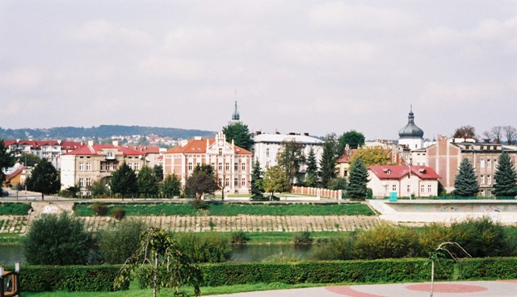
(Photo by Urszula Budzich-Szukała)

The region of Przemysl is very typical for Central Europe, with its long tradition of mixed nationalities and cultures. It is on the route linking the first Polish capital of Krakow and the royal city of Lviv which is now part of Ukraine. The whole region has elements of Polish, Ukrainian and Jewish culture, and also holds memories of the Good Soldier Svejk and his adventures in the army of Emperor Franz Josef. One of the best-known Polish journalists of Jewish origin (living now in Brussels) summarised the complex heritage of this region in the short story of his parents, who „got married under the Austrian Empire, were building their family life in independent Poland, were killed under German Nazi regime and were buried in an anonymous grave in Soviet Ukraine – all without leaving their home in Grodecka Street in Lviv”….

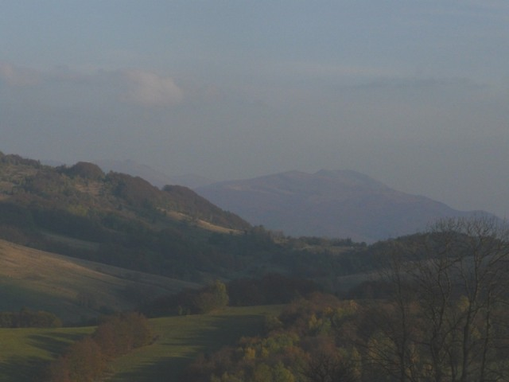
The 2007 PREPARE Gathering was organised (and to a large extent co-financed) by the Polish partner of PREPARE, the Polish Rural Forum (FAOW). The main meeting took place in Gromada Hotel in the city of Przemysl, beautifully situated near the foothills of the Bieszczady Mountains, overlooking the San river valley. The four Travelling Workshops, organised by member organisations of the Polish Rural Forum, led through old fortifications surrounding the city on both sides of the Polish-Ukrainian border and through the picturesque Bieszczady Mountains. The local organisers
(Photo by Przemysław Ołdakowski)

tried to ensure a wide range of projects, including bicycle routes dedicated to the memory of the Good Soldier Svejk; local schools and organisations focusing on education; historical monuments such as churches of various denominations and abandoned (but not forgotten) Jewish cemeteries; and a wide range of local business activities, from a telephone cooperative in Dolina Strugu, through a Ukrainian agri-processing company with a private restaurant and zoo, to Centre for Promotion and Certification of Local Products of the Bieszczady region.

The four groups of participants (involving 45 Travellers and 54 local participants) discussed such issues as local development strategies based on tourism and areas of high natural value; activities of a group of enthusiasts maintaining the old historical and military tradition around Przemysl; and the preservation of small schools which – when the number of children was getting too low and local government wanted to close them – were taken over and managed by community associations. The Travellers had also the opportunity to spend the night in rural tourism accomodation and taste many local specialities on both sides of the borders – and one of the groups was fortunate enough to have a short sightseeing tour of Lviv.

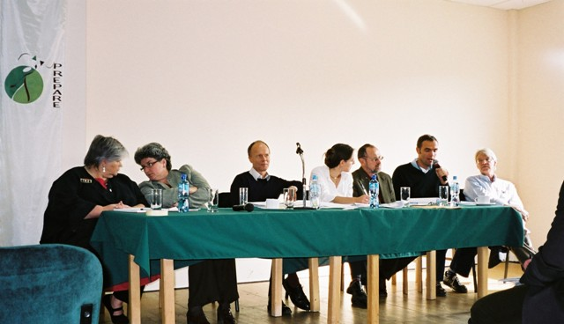
The Travelling Workshops were followed by a plenary meeting on October 11 in the Gromada hotel in Przemysl, in which almost 70 participants from 20 countries took part. The reports from the Workshops, as usual, were very lively and aimed to capture some of the spirit of the region and share it with others – and they were enriched by comments by representatives of the local organisers. Then there was a
(Photo by Urszula Budzich-Szukała)

discussion panel on the preparation of the Rural Development Programmes, with participants from several PREPARE countries (from NGOs as well as government sector) and from the European Leader+ Contact Point. There was also work in smaller groups on the chances of cooperation between civil society and governments and on expectations of rural organisations for the future PREPARE activities.

In spite of the busy schedule, there was also some time for informal networking and even for some music and singing!
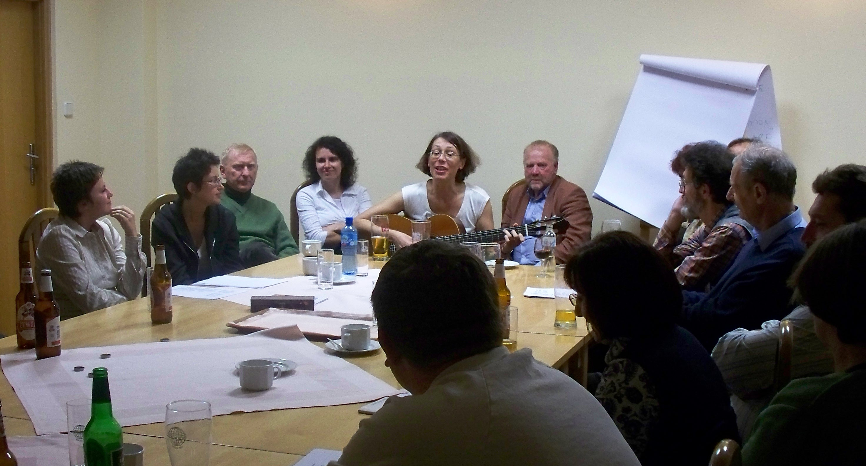
(Photo by Leokadia Juroszek)

II. PREPARE Scholarships

The first PREPARE trainee exchange programme has recently been announced. With the support from Fondation de France (through Forum Synergies), young professionals can spend up to one month in a rural development organisation from another country. Detailed information about conditions and requirements of the programme are on the PREPARE website (www.preparenetwork.org) in the section „PREPARE News”.

Interest in the Scholarships has been expressed by many organisations and individuals, but due to the end-of-the year workload some said they will not be able to meet the original deadline of December 19 for submitting the proposals. Therefore this deadline has now been extended till January 4, 2008! However, don’t forget that the exchange visits will have to take place before March 31.

III. PREPARE in Belarus

On 7 and 8 of June, 2007, a conference on „Sustainable Development of Territories. Local Agenda 21 in Belarus: Experience, Problems and Prospects” was organised in Minsk, Belarus. It was attended by almost 100 participants, including representatives from ministries and governmental bodies, regional authorities, as well as NGOs, Agenda 21 groups, universities and journalists. The objective of the conference was to spread the ideals of Agenda 21 and to disseminate its practices. PREPARE was represented at the conference by Nicola Swan.

The participants drafted a set of recommendations, stressing the need to prepare a framework of actions for informing the population about sustainable development; to develop and implement an educational programme for sustainable development; to provide a platform for the formation of an effective institutional base at national, regional and local level for the development of LA21 processes; to implement measures to support the development and implementation of LA21 initiatives; and to distribute advanced domestic and foreign experiences of practical work on the development and implementation of local sustainable development strategies.

IV. CURE of Sustainability

We reported in the last Newsletter that the PREPARE partners are working with a number of other bodies to promote a coming together of urban and rural interests, through a proposed Convention for a Sustainable Urban and Rural Europe (CURE). The aim of the Convention is to offer – at the time of the Mid-Term Reviews of EU programmes in 2009-10 – recommendations on policy frameworks and measures which will assist a sustainable approach to the future of urban and rural areas in Europe, achieved through effective partnership between governments and civil society.

The promoting bodies share a strong concern about the polarising of urban and rural interests in the mind-set of the general public and of politicians in many parts of Europe. They believe that this polarity is disguising the essential inter-dependence between cities and rural regions, and could seriously jeopardise existing efforts of the EU and member states to secure the sustainable development of regions throughout the European Union.

The Convention will bring together rural and urban stakeholders, through a series of thematic conferences based in different European regions, which will focus on how European and national programmes can be used to maximise the mutual benefit of urban and rural areas in a truly sustainable way. Two meetings with interested partners have now been held – in Strasbourg in July and in Brussels in early December – and a growing network of organisations is signing up to the initiative.
An ambitious proposal for a series of CURE seminars, to be submitted in January to DG Regio for funding under the INTERREG IVc programme. Partners in this proposal will include about 10 local or regional authorities, based in 7 different EU countries. Each partner will take responsibility for organising, between mid-2008 and mid-2009, one trans-national seminar on a distinct major theme within the framework of CURE. This family of seminars will feed ideas into a major Conference to be held in late 2009, as an input into the Mid Term Reviews of major EU programmes.
More information can be found at the CURE website, http://www.cureforsustainability.eu
Michael Dower

V. Meeting of Advisory Group on Rural Development, Brussels, 4 December 2007

In this meeting, PREPARE was represented by its Coordinator, Urszula Budzich-Szukala. The most important items discussed included:

- review of the current state-of-play of Rural Development Programmes and the process of their approval by the Commission. All National Strategy Plans and Rural Development Programmes have now been submitted and most of them will be approved before the end of the year (53 out of 94 programmes have been approved by end of November).

The EU expenditure by Axis is as follows: Axis 1 – 34%, Axis 2 – 44%, Axis 3 – 13% and Axis 4 – 6%, while the remaining 3% are Technical Assistance etc. But there are significant variations between the national (or regional) programmes; for instance, there are 5 programmes with more than 60% of funds in Axis 1 and 3 programmes where Axis 3 has between 40 and 60%.

The most important measure of all axes is „Agri-environmental payments” which take up 50% of all Axis 2. In Axis 3, village renewal (with 3.3 billion euro), basic services (with 2.4 billion) and micro-enterprises (2.1 billion) take up 66% of all funds.

The total budget in Axis 4 (LEADER) is quite high – 13.8 billion, because in addition to 8.7 billion euro public funds (including 5.4 billion EU), an additional 5.1 billion is expected to be mobilised from private funds. Througout EU, the proportion of different axes going through the Leader approach is as follows: Axis 1 – 10%, Axis 2 – 3%, Axis 3 – 65%; LAG management – 17%, cooperation – 5%.

The proportion of Leader in the total programme varies greatly, with Northern Ireland as high as 25.7%, such regions as Saarland, Sardegna, Andalusia between 13 and 15%, Ireland and Portugal – 10%, and the Netherlands – 9.9% (the countries with lowest proportion of Leader were not mentioned). The programmes vary also with respect to measures which can be channelled through LAGs: all measures are eligible for instance in Wallonia, Cyprus, Romania, Scotland and Wales; selected measures from all axes are eligible in Austria, Czech Republic, Finland, France, Italy and Spain; only measures from Axis 3 in Ireland, Portugal, Latvia, Lithuania and Poland.

- the structure and functions of the European Rural Development Network (ERDN). According to Regulation 1698/2005, the role of ERDN would be:

- Collecting, analysing and disseminating information on RD measures;
- Collecting, disseminating and consolidating at Community level good rural development practice;
- Providing information on developments in rural areas in the EU and 3rd countries;
- Organise meetings and seminars on RD at Community level;
- Setting up and running expert networks to facilitate exchange of expertise and support implementation and evaluation of RD policy;
- Supporting the national networks and transnational co-operation initiatives.

The structure of the Network would involve the following elements: a Coordination Committee as a permanent structure, a Leader subcommittee and thematic working groups (with a mandate of up to 2 years), as well as an Evaluation Expert Committee. There would also be a Contact Point providing technical assistance (selected by tender). The Coordination Committee would meet at least once a year and it would ensure coordination between national and EU levels. It would advise the Commission on the Network activities and annual work programmes, and it would have some influence on the choice of themes and operations of working groups.

The Commission intends to invite to the Coordination Committee representatives of the national RD networks from all Member States, the Managing Authorities from all MS, as well as some representatives of EU-level organisations “active in the field of rural development at EU level”. The Commission’s proposal is that there should be nine such representatives, involving: 3 organisations representing farmers and agricultural cooperatives, food industries and forestry organisations; 3 organisations representing environmental interests; and 3 “rural organisations”. In addition, there would be 1 representative from a European organisation representing Local Action Groups.

This presentation evoked much discussion. Most speakers argued for a higher representation of various rural interests, and for a greater role of the Advisory Group itself as a consultative body for the Commission – it was stressed that the Committee has a balanced representation of various interest groups and committed people. Some speakers expressed concern that the Network should have a degree of independence of the type as the European Observatory in Leader II, andthat the Coordinating Committee should meet more often than once a year if it is to do real work. There was also some concern that the national representatives will be strongly dominated by the public sector.

According to representatives of the Commission, the question of proportion can still be discussed and most of the work will be done in the thematic working groups – there would be a place for many of the rural interests in those thematic groups.

- there was also a short presentation about the Health Check of the CAP, but there was no time for in-depth discussion. A representative of DG Regio described an initiative concerning sustainable tourism.

VI. Update of recent developments

From 21 to 23 November in Evora (Portugal) there was a final conference of the Leader+ Contact Point, called „Leader achievements – a diversity of territorial experience”, with approximately 400 participants from EU and outside it.

The Swedish Rural Parliament will be organised in Lycksele (Swedish Lapland) from the 7th to the 9th of March, 2008.

Members of the PREPARE Organising Group

Forum Synergies
Hannes Lorenzen, European Parliament, e-mail: hlorenzen@europarl.eu.int

ECOVAST, the European Council for the Village and Small Town
Philip Turner, e-mail: p.turner@ruralnet.org.uk
Michael Dower, e-mail: mdower@waitrose.com

Czech National Rural Observatory
Michal Jarolimek, e-mail: novnos@tiscali.cz
Oldřich Čepelka, e-mail: oldrich.cepelka@tima-liberec.cz

Kodukant, the Estonian Movement of Villages
Liina Saar, e-mail: liina70@hotmail.com

Finnish Village Action Association
Liisa Häme, e-mail: liisa.hame@kylatoiminta.fi
Kim Smedslund, e-mail: kim.smedslund@kylatoiminta.fi

Hungarian Rural Parliament
Márta Márczis, President of the Hungarian Rural Parliament,
e-mail: marta.marczis@undp.org

Latvian Rural Forum
Valdis Kudiņš, e-mail: valdis@kudins.eu

Lithuanian Rural Communities Union
Guoda Burokiene, e-mail: lud@zur.lt

Polish Forum on the Animation of Rural Areas
Ryszard Kamiński, Regional Development Association “PARTNER”
e-mail: r.kaminski@pro.onet.pl, partner2000@pro.onet.pl

Slovakian Rural Parliament
Jela Tvrdonova, e-mail: jelatvrdonova@yahoo.co.uk

Slovenian Rural Development Network
Goran Soster, e-mail: goran.soster@guest.arnes.si
Marko Koščak, e-mail: heritage.trail@siol.net

Swedish Popular Movements Council
Staffan Bond, Folkrörelserådet Hela Sverige ska leva,
e-mail: staffan.bond@telia.com

Swedish Federation of Rural Economy and Agricultural Societies
Nils Lagerroth, Hushållningssällskapens Förbund,
e-mail: nils.lagerroth@hush.se, www.hush.se

PREPARE Coordinator
Urszula Budzich-Szukala
ul. Ciszewskiego 8
00-786 Warszawa, Poland

phone: +48 602 745 058, +48 22 593 16 45
e-mail: ula@preparenetwork.org, ula@cofund.org.pl

