
PREPARE - Partnership for Rural Europe

PREPARE News 9
October 2006

For members of the PREPARE Network and all friends of the PREPARE programme

This News:
- announces the appointment of Urszula Budzich-Szukala as PREPARE Coordinator, and the extension of the PREPARE partnership to include the Czech National Rural Observatory and the Latvian Rural Forum
- reports on the PREPARE Gathering 2006, held in the Czech Republic in June
- includes the recommendations, sent by PREPARE to the EU Commissioner and to Ministers of Agriculture throughout the EU, related to the scope and structure of the European and national rural development networks to be set up under the European Agricultural Fund for Rural Development
- reports on a meeting between DG-Agri officials and representatives of Foundations and of PREPARE
- reports also on the national Rural Development Conference held in Croatia in July
- offers other news and a list of European events in the field of rural development.

PREPARE Coordinator

The PREPARE partners are happy to announce that Urszula Budzich-Szukala has been appointed as Coordinator of the PREPARE programme, in succession to Michael Dower.

The Coordinator is responsible to the Organising Group, on which all the PREPARE partners are represented. Her role is to ensure the progress of activity within the programme that is agreed by the Organising Group.

Urszula is a graduate of the University of Warsaw, where she also gained a post-graduate Diploma in European Integration in 1998, following an MSc in Development Administration and Planning at the University of Bristol in England. For 8 years, she was Head of the International Department of Warsaw Agricultural University. Since 1991, she has worked with the Cooperation Fund in Warsaw, most recently as Director of the Fund’s Rural Programmes Bureau. She is very familiar with European policies and practice in rural development, and has experience in project development, training programmes and other activity in this field in Poland and in other countries, including Belarus and Romania.

In 2002, she was an initiator and founding member of the Polish Rural Forum, a nation-wide platform of rural organisations, which is a partner in the PREPARE programme. For the last three years, she has acted as Secretary of the Forum, and has represented the Forum on the PREPARE Organising Group.

Hannes Lorenzen, Chairman of the Organising Group

Message from the new PREPARE Coordinator:

Dear PREPARE friends,

The change of Coordinator means three things:

- one, the change shows that PREPARE has grown in the past years, and has become a “professional” organisation, with a proper (although very small indeed) office and staff; which is made possible thanks to the support of the C.S. Mott Foundation;
- two, that in spite of this change, PREPARE will continue in its mission to strengthen civic society and promote transnational cooperation in rural development, and the new office in Warsaw will serve all the existing PREPARE partners as well as the emerging rural initiatives in the new EU neighbour countries;
- and three, that this is an opportunity to express heartfelt thanks to Michael Dower, who has made PREPARE what it is, and who – although retiring as Coordinator – fortunately will continue to support us with his wisdom and experience as representative of ECOVAST on the PREPARE Organising Group.

I would like to encourage all of you to share your views on rural development in Europe and on the activities and role of PREPARE. I rely on your guidance and support.

Urszula Budzich-Szukala

PREPARE Partners

At their meeting in Prague in June, the PREPARE partners accepted with pleasure requests from two recently-formed national rural networks to join the partnership in the PREPARE programme.

The Czech National Rural Observatory was set up in 2005 by twelve individuals who are active in rural development at national or regional level. The decision to create the Observatory followed three years of initiatives by these individuals to bring together people involved in rural action, including national and regional conferences, training programmes and promotion of LEADER-type local action groups. PREPARE had given financial support to this set of initiatives, from the funds given to us by the Mott Foundation. The new Observatory operates, through a National Network for Rural Development, as the network of more than 40 Local Action Groups throughout the Czech Republic. The Observatory and the Network acted together as hosts of the PREPARE Gathering 2006 (see description below).

The Latvian Rural Forum was set up in early 2005, following a process of discussion which had been initiated the year before jointly by PREPARE and the Latvian Ministry of Agriculture. Its membership includes 14 registered NGOs, and it is process of becoming a national rural platform involving other organisations such as small village schools. The Forum organised very effective Travelling Workshops in the Daugavpils and Bauska regions of Latvia as part of the PREPARE Gathering 2005.

PREPARE Gathering 2006

The PREPARE Gathering 2006 was held at Velehrad, in south-eastern Moravia, Czech Republic, 21 to 23 June 2006. The theme of this Gathering was ‘The evolution and strengthening of Local Action Groups, and their role in Rural Development Programmes’. This reflected the process, currently in hand in all member countries of the European Union, to prepare national rural development programmes within the framework of the EU’s Rural Development Regulation for the period 2007 to 2013. This Regulation requires that each national programme shall make provision for LEADER-type Local Action Groups as deliverers of parts of that programme.

In response to this requirement, and to the success of LEADER in EU-15 since 1991, Local Action Groups are emerging in all of the 25 member states. A similar process is in hand in the accession countries - Bulgaria, Croatia and Romania. Further south and east, there is growing interest in the Balkans, the CIS countries and Turkey in the idea of territorial, integrated, partnership-based approaches to rural development, of which LEADER is one major expression. The Czech Republic, which was the venue for this Gathering, has a rapidly-growing number of Local Action Groups. These Groups have formed a national Network, allied to the Czech National Rural Observatory which was set up last year and which hosted the Gathering.

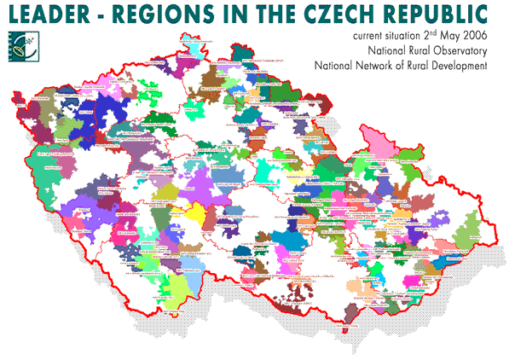



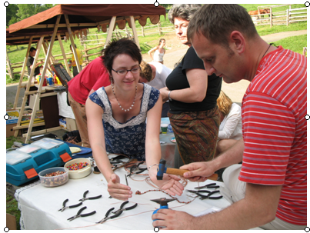
The Gathering attracted 71 participants from 22 countries, including Turkey for the first time. 52 of these participants took part also in three-day Traveling Workshops, which started in Prague on Monday 19 June with a reception and introduction at the Senate House, hosted by Senator Václava Domšová, Chairperson of the Senate’s Standing Committee for Rural Development. The party then split into 5 different groups, each traveling by minibus to different parts of the Czech Republic and being hosted by a total of 16 Local Action Groups, before arriving on the third day at Velehrad, which itself falls within the operating area of the Buchlov Local Action Group in Moravia.

The Gathering itself focused on the emerging pattern of national rural development programmes, and on how the widespread family of Local Action Groups can flourish and contribute over the next decade to the process of strengthening the social and economic structures of rural Europe. The meeting was highly participatory, most of the time being spent in multi-national workshops, in order to compare experience and to clarify how best to promote the principles and methods of LEADER in the very varied contacts of the 22 countries. It became clear that governments vary greatly in their understanding of, and enthusiasm for, the LEADER idea. The Gathering ended by assembling a set of ideas on how the LEADER approach can be promoted to governments and others.

A report on the Gathering and the Travelling Workshops has been prepared and will be made available in CD form by the Czech National Rural Observatory.

Report: Michael Dower
Pictures: Inga Kawalek

European and National Rural Development Networks

The Rural Development Regulation provides for the setting up, on the initiative of the European Commission at EU level and by governments in each member state, of formal Rural Development Networks. These will stimulate the flow of information and exchange between all individuals and organisations who are involved in rural development. They will thus have a role similar to, but wider than, the LEADER Observatories that have operated at EU level since 1992.
The PREPARE partners warmly welcome this concept. We are ourselves committed to the promotion of information and exchange, and to active partnership between all stakeholders in rural areas. We believe that these networks, if they are well structured and managed in an open and dynamic way, can do much to stimulate the active partnership between public, private and civil sectors on which successful rural development depends. We therefore wrote in July to the EU Commissioner and to Ministers of Agriculture throughout the EU and in Bulgaria and Romania, to offer suggestions related to the scope and structure of the rural development networks.
Beneficiaries and actors. We urged that the Networks should be designed to serve, and to involve, a wide range of stakeholders in rural development. This should include regional and local authorities, commercial interests, trade associations etc, and also civil society at international, national, regional and local level, NGOs, LEADER groups etc. These should all be seen not only as beneficiaries or receivers of a service, but also as contributors to a process of stimulation and exchange of information and ideas. If this happens, then the system will be truly top-down and bottom-up, and will merit the name of 'Network'.
Mode of operation. We urged that the Networks should be open; flexible; responsive to the needs of the beneficiaries and contributors; user-friendly in the format, content, language etc of the services and activities offered; reaching out in an imaginative way; and able to act quickly as needs change and opportunities occur.
Exchange. We urged that the activity of the Networks should have a strong emphasis on exchange of experience and ideas between all involved in rural development, drawing (for example) on the experience of such exchanges within the LEADER programme, and on other rural development activities. This exchange should be stimulated within each country and on a multi-national basis. This implies that the national networks should be seen as a family, working closely together with help from the European Network.
Management. We suggested that the network services in each country should be contracted out, by means of an open tendering process; and that competitive tenders should be welcomed not only from commercial companies and consultancy firms but also from civil associations and non-government bodies. We believe that this approach is fully compatible with proper accountability for public funds. We very much hope that the tendering process can be put in hand early in 2007, so that the national Networks can be in operation before the end of that year: this could do much to stimulate an active response to rural development programmes among all stakeholders. There is need to achieve a strong involvement of private and non-governmental actors in rural development.
Steering Committee. We urged that those who operate each national Network should benefit from regular consultation with, and advice from, a Steering Committee. This might be chaired by the Ministry of Agriculture, and might include representatives of each broad type of beneficiary and contributor (e.g. the local and regional authorities, commercial interests, farmers' organisations, environmental groups, advisory organisations, rural movements, etc).
Consultation. We expressed our belief that those who will be the beneficiaries of, and contributors to, each Network should have the opportunity to comment on the proposed scope and structure of the network. We therefore urged that each government consult with all main stakeholder groups before deciding on the scope and structure of the national Networks.
PREPARE's offer. We stated that the PREPARE Partnership, and the individual partner organisations, stand ready to contribute actively to the networking process. We know that civil society organisations can make a major contribution to the partnership upon which successful rural development depends.

Meeting with Foundations

Last year, PREPARE - acting with Sandor Köles, who was then Director of the Carpathian Foundation - proposed to the European Parliament that there was scope for exploring the contribution which Foundations, companies and banks make to the funding of rural development. The Parliament took this up, and included a provisional budget line for study of this issue. As a consequence, Dirk Ahner, Deputy Director-General of DG Agri at the European Commission, initiated in June a meeting (which he chaired) between EC officials, representatives of a number of Foundations, the European Foundations Centre and PREPARE, plus Sandor Köles, who is now Director of the International Rural Resource Center in Hungary.

This was the first such contact between Foundations and the Commission in this field, and was welcomed by both sides. It was agreed that a further and more detailed discussion should take place; and that thought should be given to the possible holding, in 2007, of a "FAIR" in which all private foundations, the LEADER Observatory and Leader Groups could participate in order to exchange views and experiences and present good practices, with plenty of time for meetings and contacts to facilitate networking.
National Rural Development Conference in Croatia

In the last News, we reported on the support that PREPARE had given to the creation of a formal Croatian Rural Development Network, and to the initiative by that Network to hold a national Rural Development Conference. This two-day Conference, the first of its kind in Croatia, was held in July in the Town Hall in Zagreb. 130 people attended, representing Ministries, local authorities, civil organisations of many kinds, companies and universities. There was intensive debate about the problems facing rural areas in Croatia; the existing policies and programmes of the government and the European Union; and the opportunities that will be opened by the future programmes, as Croatia moves towards accession to the EU.

Many participants have expressed thanks to the Network for organising this timely and thought-provoking event, and a number of NGOs have applied to join the Network.

Information from Ivana Laginja, President, Croatian Rural Development Network,
e-mail ivana.laginja@zg.htnet.hr

ERA meeting

On October 2 in Helsinki another step was made towards the establishment of the European Rural Alliance (ERA). This Alliance aims to „bring together European civil organisations which implement integrated and multisectoral rural development“. The meeting in Helsinki was organised by the Village Action Association of Finland (SYTY) which supports the creation of ERA. It was chaired by Eero Uusitalo supported by Liisa Häme, and attended by Jela Tvrdonova, Staffan Bond, Urszula Budzich-Szukala and Vanessa Halhead, as well as by Henny Stroes from the Dutch National Association of Small Villages (LVKK) and Samuel Jaulmes from the French NGO network CELAVAR.

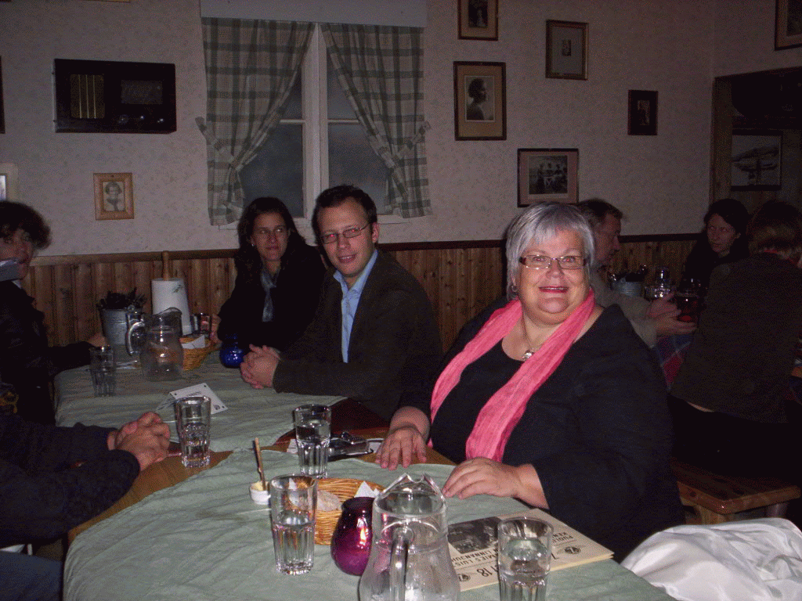
The participants discussed the current situation related to the programming of rural development funds for 2007-2013 and the options related to setting up ERA as a legal entity, as well as future activities and financing. PREPARE, together with ELARD and other networks, will continue to take part in these discussions and help to set up ERA as the „European Rural Voice“.

Photo: Jela Tvrdonova

The Slovakian Rural Parliament

The bi-annual meeting of the Slovakian Rural Parliament will take place in the village of Hepla in Central Slovakia on the 20 and 21 of October, 2006. Its main theme will be the preparation of Slovakian rural areas for the Leader programme. We wish our Slovak colleagues a successful meeting!

“LEADER in the new member states”

The PREPARE partners have strongly welcomed the plans for a major Conference on “LEADER in the new member states”, initiated by the LEADER+ Observatory and Contact Point in Brussels. This event, with about 300 participants (mainly LAGs and managing authorities, but also formal and informal networks) from all the new EU member states and accession countries, will take place in Hungary from 13 to 16 of November. The team of speakers, moderators and rapporteurs will include a number of PREPARE partners and network members.

Participation in the conference by invitation only (registration closes on October 30). Information from Kristiane Hallermann, Events Officer, Leader+ Contact Point, 81 Rue du Marteau, B-1000 Brussels, Belgium. Tel +32 2 235 2027, e-mail k.hallermann@leaderplus.org

For information about PREPARE, please contact Urszula Budzich Szukala, PREPARE Coordinator, at:

PREPARE Office
Ciszewskiego 8
02-786 Warszawa, Poland

e-mail: ula@cofund.org.pl
phone: +48 602 745 058
PREPARENews9

