
PREPARE - Partnership for Rural Europe

PREPARE News 12
June 2008

To members of the PREPARE Network and all friends of the PREPARE programme

Dear Friends,

This Newsletter has a special focus on the activities of PREPARE in South-Eastern Europe. This issue is dealt with in Section 1. The other sections contain:

- information about the OECD conference on “Innovative Service Delivery: Meeting the Challenges of Rural Regions” (Section 2)

- and a review of events and initiatives of the PREPARE partners (Section 3).

(1) PREPARE activities in South-Eastern Europe

In the first years of our work, a major emphasis in PREPARE’s activity was focused on strengthening civil society in rural areas of the ten central European countries which were moving towards membership of the European Union. After their accession PREPARE has expanded the geographic focus of its work to embrace those countries which may be seen as the ‘new neighbour states’ of the European Union, particularly Croatia, Serbia, Bosnia and Herzegovina, Albania, and Macedonia. Many of PREPARE’s contacts in these countries date back to a programme of “Localizing Sustainable Development” carried out by UNDP over the period 2002 to 2004.

In this Newsletter we would like to update the reader on recent activities undertaken by PREPARE or its partners in some of the above-mentioned countries.

Croatia
In 2006, PREPARE helped in the establishment of the Croatian Rural Development Network, and the hosting by that Network of a two-day national conference on rural development. Since Autumn 2007, this Network, together with local actors from the community of Gorski Kotar, has participated in a rural development project “Sustainable future for rural areas in Croatia”, financed by the Matra programme of the Dutch Ministry of Foreign Affairs and implemented by Milieukontakt in cooperation with the Czech Centre for Community Organising and with PREPARE. The aim of the project is to enable Croatian regions (starting with one pilot region) to develop in accordance with their recognised needs and EU standards (in particular the Leader approach) and to prepare for the effective use of Croatian as well as EU funds.

It is expected that this project will result in the development of one region’s sustainable development plan, prepared with the participation of all relevant regional stakeholders, and the dissemination of this experience to other Croatian regions. An indirect result will also be increased participation of Croatian NGOs and communities in international networks and platforms, and increased communication, consultation and cooperation between NGOs, communities and authorities in Croatia, at regional and national level.

In March 2008, two important events were organised in Zagreb by the Croatian Rural Development Network in cooperation with PREPARE: the first one was a workshop on “The Role of civil society organisations in rural development” (March 12), and the second was a round table “Rural development in Croatia on the path of accession” (March 13). The events were supported by the Croatian organisation ODRAZ, Milieukontakt within the Matra project and by PREPARE. They were also attended by two representatives from Bosnia-Herzegovina (from the rural section of the UNDP project SUTRA).

The workshop on the role of civil society provoked intensive discussion between member organisations of the Croatian Rural Development Network (HMRR) about their future policy and activities. Representatives of the PREPARE partners provided examples and advice based on their own experience. A SWOT analysis of HMRR was carried out. From the discussion, the following points emerged (as summarised by Michael Dower and Visnja Jelic-Mueck):

- it is of crucial importance that the membership base of HMRR should be expanded; NGOs at all levels should be invited as long as they focus on rural development; it is debatable whether commercial organisations or their chambers should be included as well; internal links between members must also be strengthened;
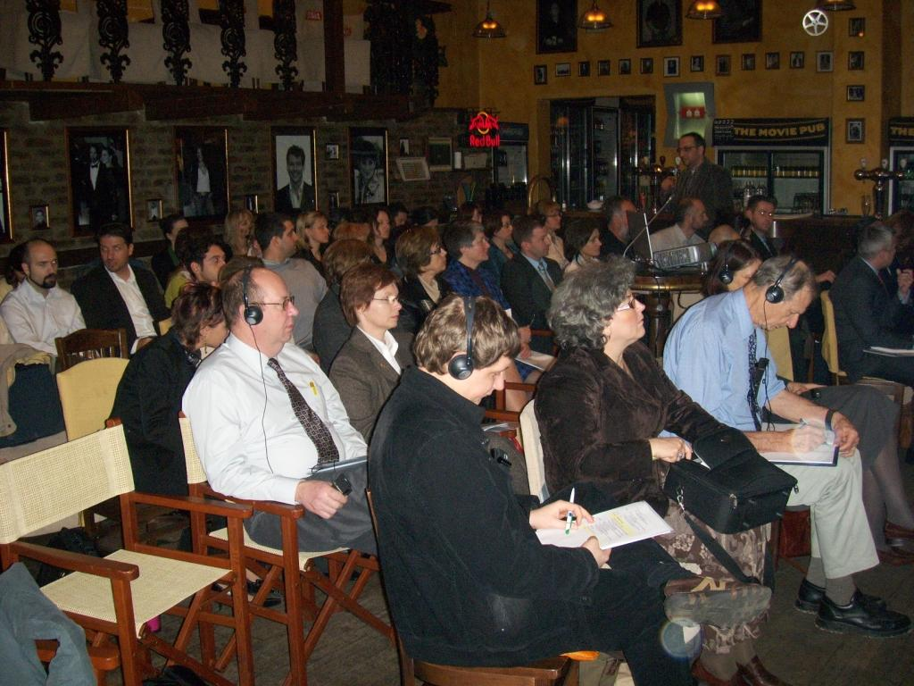
- HMRR should develop its own strategy for rural development (starting with a “vision” for rural Croatia); in this way it would (a) gain visibility and influence, and (b) achieve better understanding between the members;
- joint projects should be developed, involving several (but not necessarily all) members; it is important that they should have strong roots at the local level, but also be visible at the national level;
- rural organisations in Croatia should be involved in the programming and monitoring of EU funds (which requires well-qualified and experienced representatives, e.g. on the monitoring committees);
- in particular they should closely follow Leader and its evolution, and also be ready to play an important role in the future National Rural Development Network;
- the Croatian network should maintain close links with its neighbour, the Slovenian Rural Development Network, and it should apply to become a partner in PREPARE.

The Round Table on the following day was attended by the HMRR and PREPARE representatives, as well as representatives of the Croatian Ministry of Agriculture (including Mr Tugomir Majdak, head of the rural development department) and many local actors from various rural areas in Croatia, who presented their projects and organisations.

According to Michael Dower from PREPARE, who summed up the discussion, much progress has been made in Croatia since the Rural Development Conference in 2006. EU money has been put to good use, and there are high hopes for the new IPA-RD programme. The speakers dealt with the key aspects of rural life: social, economic and environmental. It is necessary to keep those three aspects in place to ensure integrated and sustainable rural development. It is of equal importance to focus on the rural people, and to take into account their individual realities and hardships.

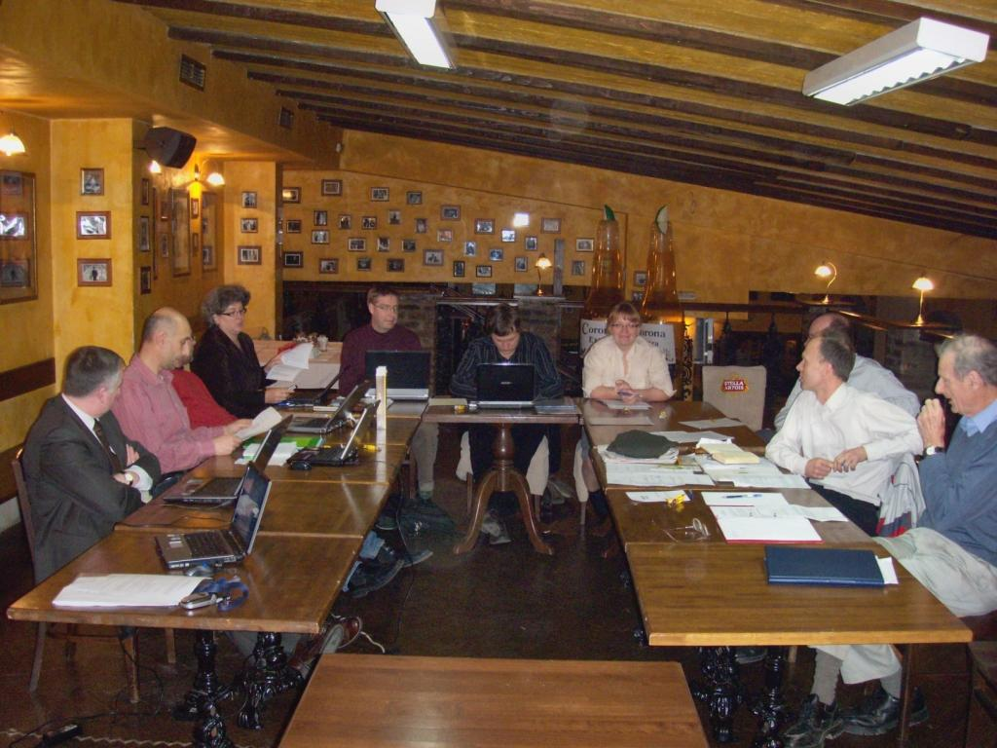
It was also agreed that the Leader approach offers great potential for Croatia. Initially, 10 Local Action Groups are to be chosen by 2009. However, based on the experience of other countries Croatia might set itself the long-term aim to cover all rural areas with Leader groups. Capacity building for those emerging groups is of key importance. A wide range of needs were revealed during the presentations of local actors, ranging from legal issues through strategy, education, promotion, to standards and basic terminology. In many of those issues entrepreneurs and NGOs have to look for their own solutions, but the government must provide the necessary climate of helpful laws and efficient administration. An important role will also be played by the National Rural Development Network, which is to be established according to the EU regulations and which can help to stimulate international exchange with similar networks in other countries.

In addition to these two events, PREPARE Organising Group also held its own internal meeting in Zagreb on March 13 and 14.

Serbia

In Serbia, at the initiative of several rural NGOs a series of meetings and other activities have been carried out in order to strengthen the position of rural civil society and to help in the creation of a national network of rural organisations. At the end of March 2008, a national conference was organised by the Educational Centre in Leskovac with assistance from PREPARE. The conference theme was “Rural Development Networks – chances and possibilities”. It was held on March 27th in the Media Centre in Centar Sava in Belgrade. The purpose of the conference was to introduce basic issues of rural development and networking, including experience from other countries, and then to develop, through group work, a set of recommendations for Serbian civil society as well as for the Serbian government about benefits, values and ways to represent rural interests and to support allied rural communities. The questions posed for the group work were as follows:

- What are the expectations towards the future network and what, according to the participants, is the network supposed to advocate?
- What preconditions should be fulfilled to enable formation of the network? What values and interests are of highest importance to rural communities?
- In what way can the state assist efforts of linking rural communities, while ensuring the independence of the network and system of decision making?
- Can rural Serbia represent itself properly? Who can help? Who can make difficulties?
- Is it possible to make rural development network independent from Government/ political parties as well as international development partners?

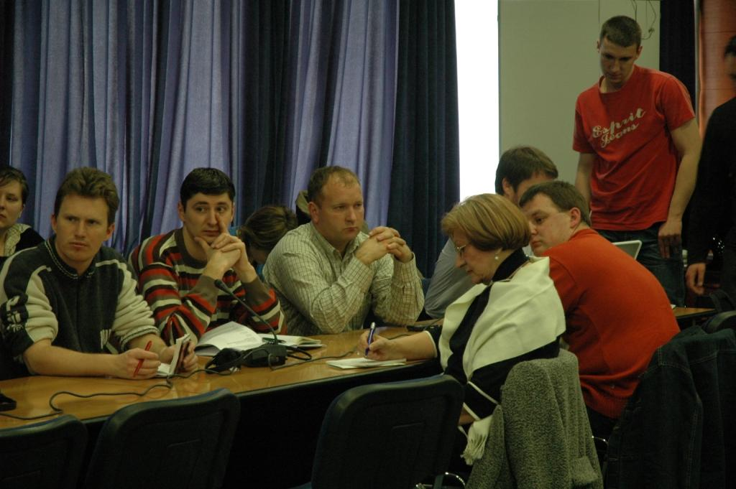
The meeting was attended by 51 participants from civil society organisations and initiatives all over Serbia (70 organisations and 11 informal groups had been invited). The Ministry of Agriculture was represented by Mr Dragan Stefanovic, who made a presentation dealing briefly with tasks of the rural development department in the Ministry; present policies and programmes for rural development; efforts to increase the number of beneficiaries and applicants for EU funds; and the Ministry’s plan to create the national rural network through 60 field offices established in selected NGOs. Then the PREPARE Coordinator made a short presentation on the importance of civil society in rural development; rural networks and benefits of networking; and the activities of PREPARE in the new member states and candidate countries.

Each of the two smaller groups focused on one specific issue: one was “Networking as a method of advocacy of rural communities’ interests” and the other “Participation of the national government in support of advocating rural communities’ interest”. Conclusions from the first working group included:

Expectations towards the network: gathering and spreading information, cooperation on issues of common interest, resource mapping, connecting knowledge and skills, provision of education based on targeted needs, raising civil activity with particular attention to youth, promotion of integrated (cross-sectoral) approach, dissemination of good practices and strengthening the position of civil society in relation to local authorities.

Actors identified: the network should be open to all who share common principles, in particular civil society organisations but also the public and private sectors, with special attention to youth groups.

Common values: the network should respond to the interests of its members, should be decentralised, should represent values of local communities (at local level), as well as multiculturalism and recognition of differences in resources and needs (at national level). Knowledge, skills, trust, commitment and responsibility were also stressed.

Conclusions from the second group developed recommendations for central government, which included:
- the need to have a clear mechanism for support of rural communities;
- the need to ensure continuity in the implementation of strategic plans of the Ministry of Agriculture, Forestry and Water Management;
- to support the initiative on Resolution for Villages;
- to support education about the importance of joint action;
- to support pilot projects containing innovative elements and integrated approaches to rural development;
- to support efforts for non-party political initiatives;
- to support development and implementation of local and municipal development plans;
- to secure funds for projects prepared in line with the Leader approach;
- and to support the establishment of an Agricultural Chamber (or Labour Union).

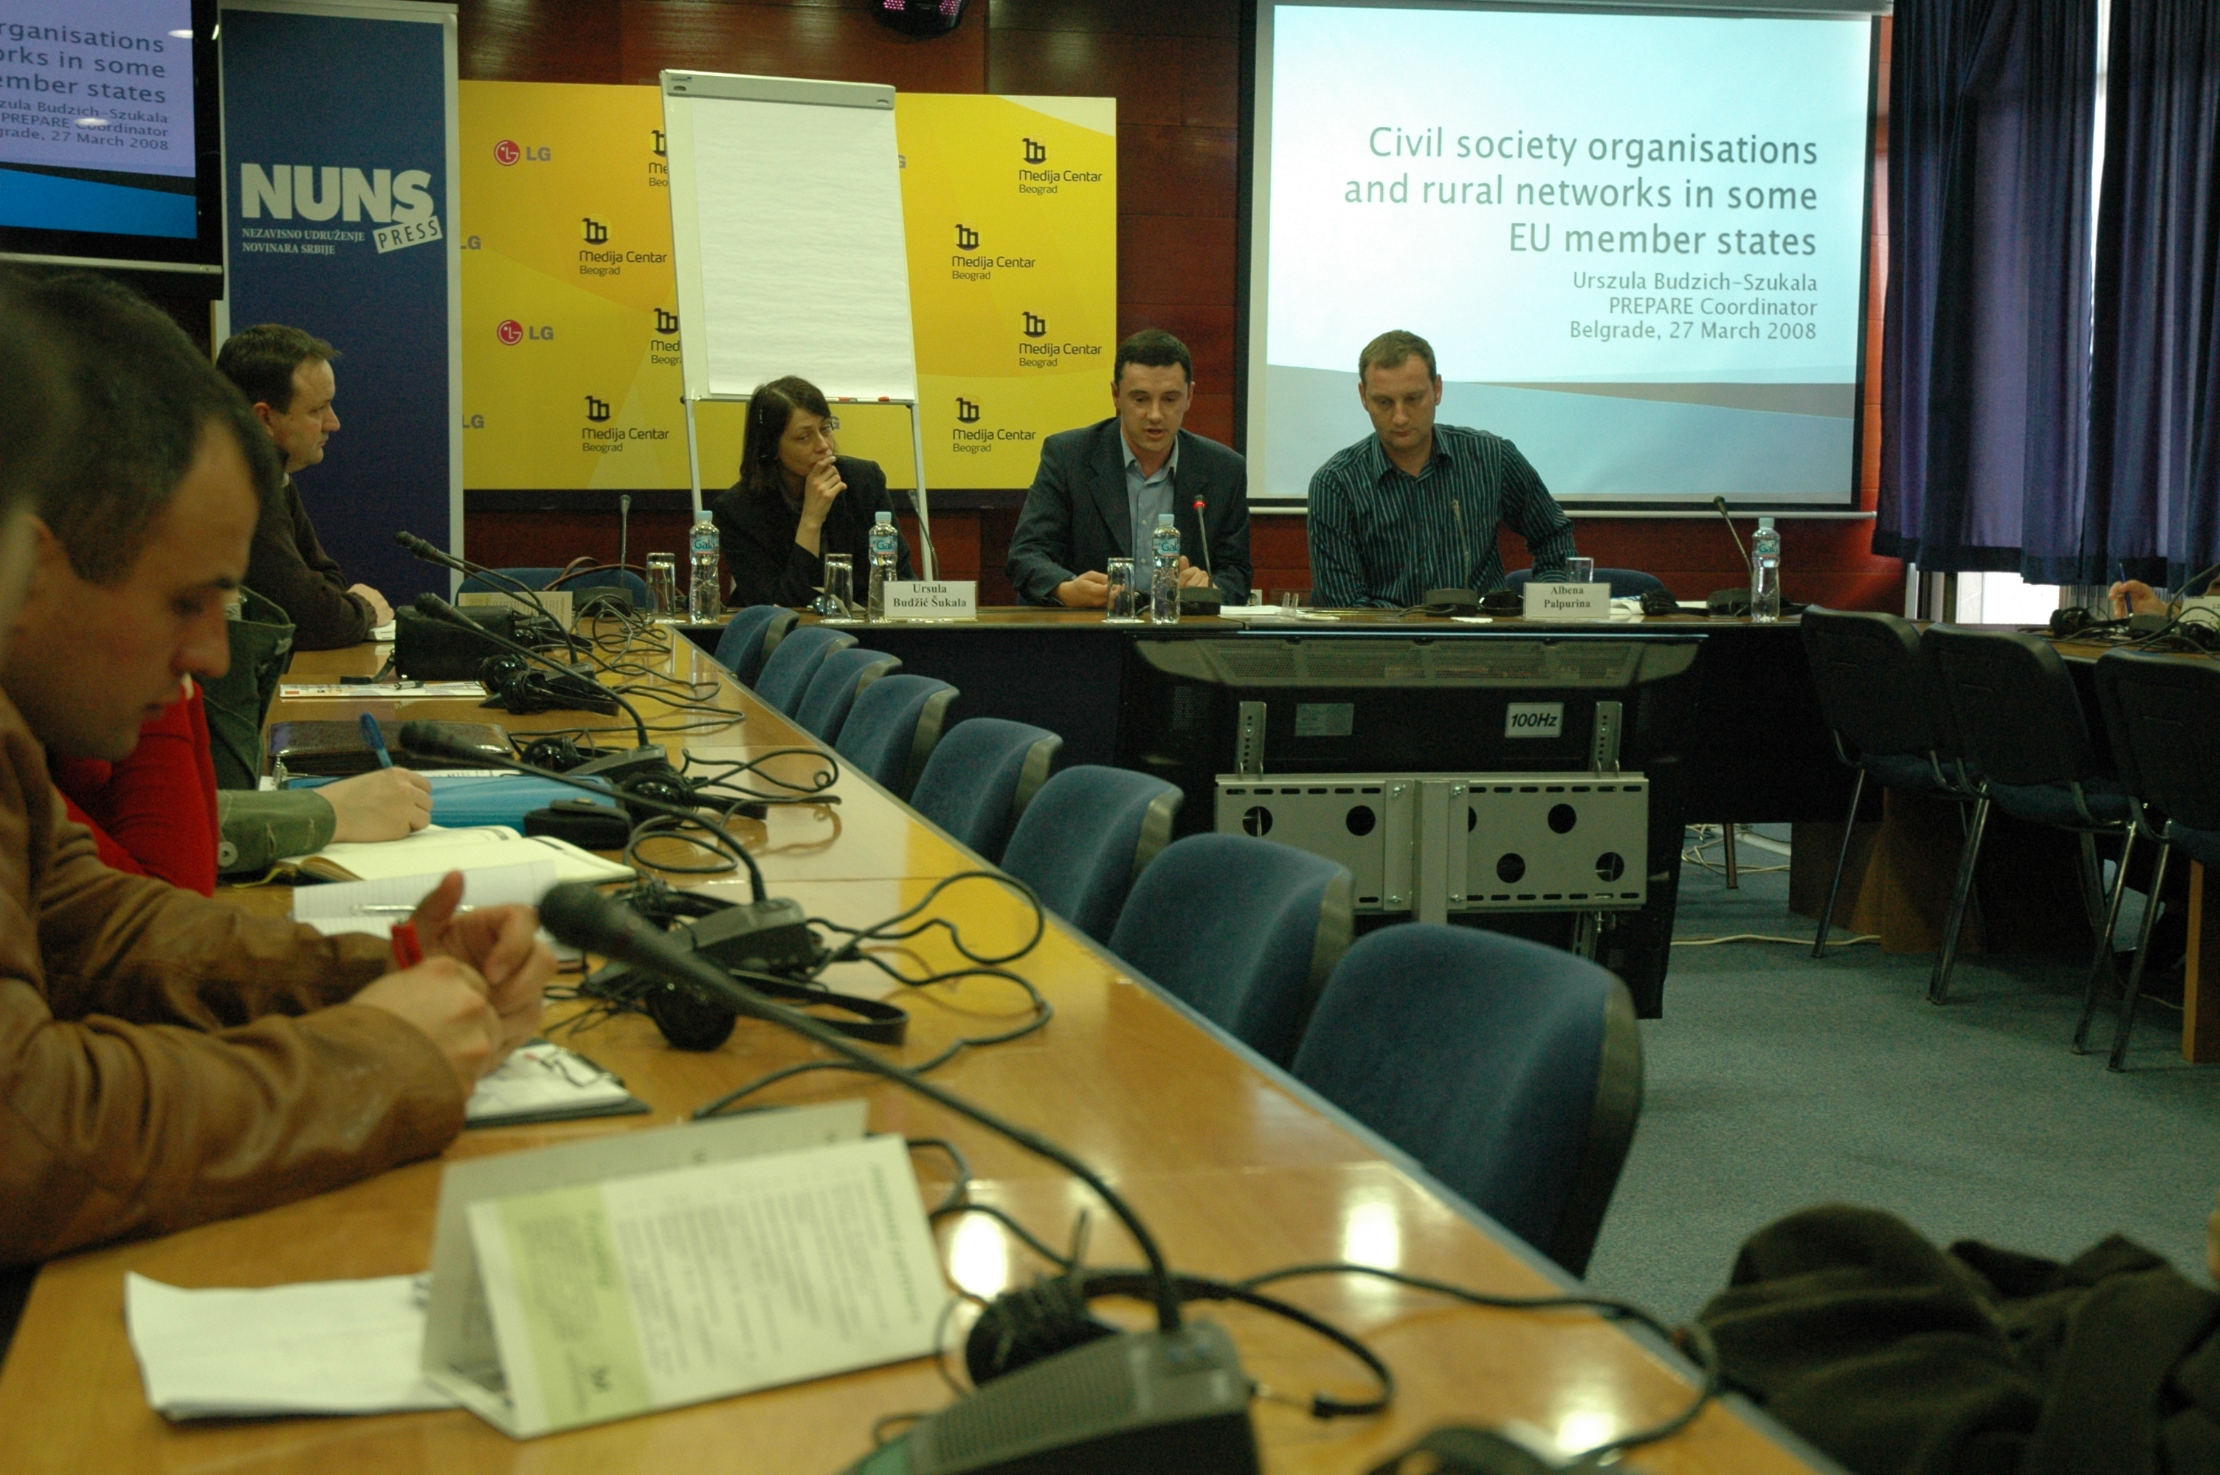
Both sessions were very well-attended and the discussion, facilitated by professional moderators, was sometimes very lively. The final session consisted of presentations of results of the working groups and conclusions. The participants expressed strong interest in the creation of a national rural development network with a strong focus of NGOs and other organisations independent from the government and political influences.

Albania

In 2007, the Hungarian partner in PREPARE – Hungarian Rural Parliament (HRP), with support from PREPARE, carried out an introductory project on rural civil society in the village of Lin, Korca region. The objectives were to raise awareness of sustainable development and the need to mobilize citizens’ participation in local planning processes, including capacity building and networking. The Leader approach was introduced, and possibilities to launch a broader project framework were discussed.

The target group was a local NGO in Lin, but participants included also representatives from the Regional Council of Korca, nearby communes, and the national Institute for Democracy and Mediation (IDM). All of them were keen to go on disseminating the lessons learned and to take part in a nationwide project on the issues.

PREPARE decided to support a wider activity by the HRP together with IDM and All Sweden Shall Live. This initiative involved the organisation in Pogradec, on February 9, 2008, of a conference on “Presentation and Promotion of Rural Networking and Pilot Leader Approach in Albania”.

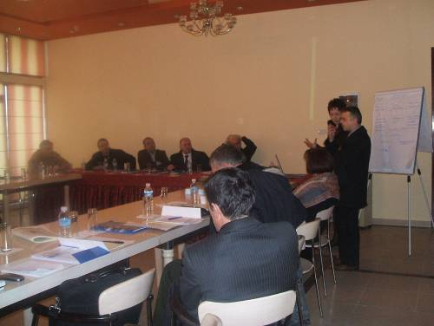
The participants to the conference were representatives from Albanian rural civil society, business and public sectors from the regions of Korca, Lezha and Elbasan. The conference was also attended by experts from the Ministry of Agriculture, Food and Consumer Protection, MADA (Mountain Area Development Programme) and the Department of Coordination of the Strategy for Foreign Donors. The aim of the conference was to raise awareness and knowledge of integrated rural development as well as different methods and models to encourage citizens to take part in the development of their own area, to promote local government and mobilise citizens and businesses to create partnership for networking at local, regional and national level, and to lay the ground to widen the network to international exchange of experience through PREPARE.

The first part of the conference consisted of presentations by Mr Sotiraq Hroni from IDM; Mr Grigor Gjeci, rural development expert at the Ministry of Agriculture; Ms Marta Marczis from the Hungarian Rural Parliament and PREPARE, and Mr Kjell-Roger Karlsson. Presentations and discussion were followed by two kinds of working groups: first, mixed groups – with participants coming from different regions – discussed several concepts of the Leader approach; then regional groups from Elbasan, Lezha and Korca worked together. The conference ended in agreeing the tasks of different stakeholders for future action.

The Albanian actors were also invited to take part in the biennial meeting of the Swedish Rural Parliament “All Sweden Shall Live” in early March 2008.

Romania

Two members of the PREPARE Organising Group – Hannes Lorenzen and Michael Dower – have been assisting the Ministry of Agriculture in Romania in the shaping of the National Rural Development Network, as part of the national Rural Development Programme. The aim of the Network is to enlist the energy of all stakeholders in the rural development process, and to promote an effective flow of information, exchange of ideas and good practice, and cooperation among the stakeholders. The Network is expected to embrace at least 400 stakeholder organisations, who will be represented through about 12 sectors on the Steering Committee of the Network. Significant funds have been committed by the Ministry to finance the Support Unit for the Network, to be set up by contractors after a tender process.

In a separate initiative, the Ministry supported a seminar in January on the future of small-farming communities in Romania. This event, with Michael Dower as moderator, focused on the needs of the over 3 million subsistence or semi-subsistence farms in Romania. It highlighted the need for an integrated approach to meeting these needs, bringing into play the measures in all 4 Axes of the national Rural Development Programme.

For more information on these initiatives, write to Michael Dower at mdower@waitrose.com.

Regional Rural Development Standing Working Group

Until recently, most of PREPARE’s activities in South-Eastern Europe focused on the civil society organisations. However, a link has also been established with the Regional Rural Development Standing Working Group of South-Eastern Europe. This is a platform of networking and regional cooperation established in 2005, which consists of representatives of governmental institutions responsible for rural development in the following countries/territories:
- Albania – Ministry of Agriculture, Food and Consumer Protection;
- Bosnia and Herzegovina – Ministry of Foreign Trade and International Relations;
- Bosnia and Herzegovina, Republic of Srpska – Ministry of Agriculture, Forestry and Water Management;
- Bulgaria – Ministry of Agriculture and Food Supply;
- Croatia – Ministry of Agriculture, Fisheries and Rural Development;
- Macedonia – Ministry of Agriculture, Forestry and Water Management;
- Montenegro – Ministry of Agriculture, Forestry and Water Management;
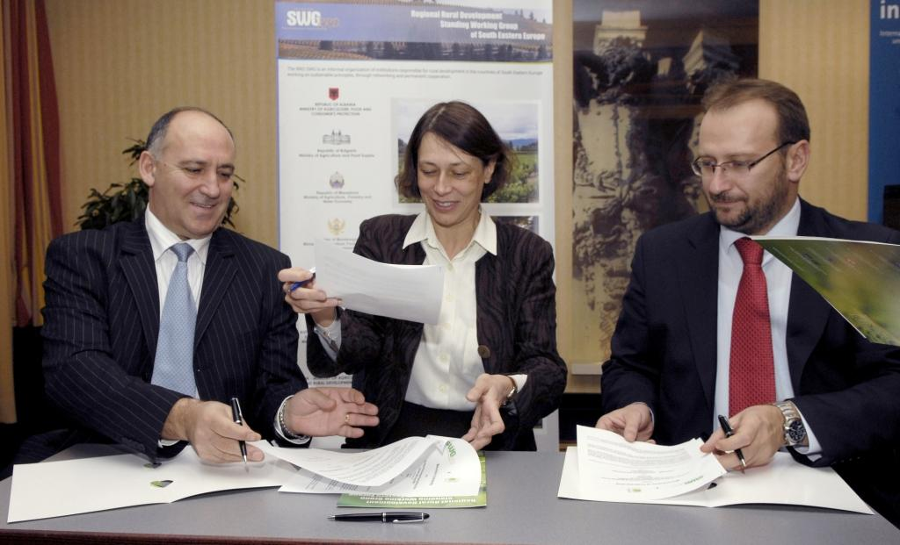
- Romania – Ministry of Agriculture and Rural Development;
- Serbia – Ministry of Agriculture, Forestry and Water Management;
- Serbia, Autonomous Province of Vojvodina – Provincial Secretariat of Agriculture, Water Economy and Forestry;
- UNMIK Kosovo – Ministry of Agriculture, Forestry and Rural Development.

During a conference in Dresden (Agricultural Policy Forum for South-Eastern Europe), organised by SWG jointly with the German partners InWent, GTZ and the research institute IAMO, on November 17, 2007, a memorandum of cooperation (previously approved by the PREPARE Organising Group) was signed between representatives of the RRD SWG and the PREPARE Coordinator.

(2) OECD Rural Development Conference

The sixth OECD Annual Rural Development Conference, focused on “Innovative Service Delivery: Meeting the Challenges of Rural Regions” was organised jointly with the German Federal Ministry of Agriculture in Cologne on April 3 and 4, 2008. The idea of the conference came from suggestions of participants at previous events, who stressed the importance of providing services to rural regions. In the introductory paper to the conference we read that “while rural communities cannot exist without appropriate public services, delivering these core services to rural areas presents a number of unique challenges. The combination of geographic remoteness with an ageing and shrinking rural population and low tax base questions the financial sustainability of rural services even in the most developed countries. There are major gaps that need to be addressed in the field of mobility, education, training and healthcare as well as services to businesses”.

The conference was attended by a large group of actors: policy makers, researchers and NGOs active in rural development. There were sessions focusing on:

- trends and challenges of rural service delivery (dealing with such issues as access, cost and quality of service; minimum standards and policy tradeoffs; models of service provision; and monitoring and incentive mechanisms);

- delivering quality education to rural regions (dealing with providing education services that are more responsive to local demand, supplementary funding schemes that reflect the “real” costs of educating rural students; shortening the travel demands related to rural education; narrowing performance disparities in rural schools; decreasing the “brain drain” phenomena in rural areas, and upgrading the skills and competencies of the rural population;

- innovative strategies for healthcare and social service delivery (including questions such as “at what levels should health and social services be present in rural areas?”, “how to deal with the special challenges facing those living in the smallest and most remote rural areas?”, “what is the experience with alternative models for delivering rural health care?” “how to promote greater flexibility in roles and responsibilities?”, “what is the direct and indirect contribution of health and social services to local economies?” etc.);

- increasing rural access through ICT and transportation (here the questions included: “how to strike the balance between equity and efficiency in planning and operating public transport infrastructure?”, “what alternative transportation options for rural areas?”, “what is the impact on rural areas of incentives to move to public transit?” “what role for subsidised supply, direct public provision or enhanced private competition in the ICT sector?”);

- fostering business and financial services in rural areas (dealing with fostering of locally based entrepreneurial culture and the creation of rural businesses that are competitive globally; providing services that are tailored to the needs of rural businesses; balancing the use of direct aid measures to support businesses with indirect aid policy measures; encouraging large scale and typically urban-based funders to provide capital to rural areas; coping with the lack of an enabling business environment; helping business networks);

- service delivery and the future of rural regions – a framework for action (the summary session).

Possibly the most interesting summary of the two days’ discussion was presented in the final session by Nicola Crosta, Head of OECD’s Rural Development Programme. He stressed that the following elements should be taken into account:

(1) the diversity of rural areas (and therefore different needs);
(2) the fact that rural services are helping not only the rural populations, because rural areas have an impact both on urban areas and on the global scene;
(3) the need to balance equity (i.e. social objectives, ensuring minimum standards) with efficiency (cost-effectiveness, trade-offs);
(4) in analysing the impact of rural services one should not only consider the costs, but also the benefits (such as jobs created directly or indirectly by these services, enhancement of social capital and attractiveness of rural areas etc.);
(5) the need to consider the choices of the local population (what kind of area do they want to live in?) and local assets, and not merely the economic aspects of services;
(6) it is necessary to look beyond the transport infrastructure bias; it is true that transport infrastructure is a necessary condition for rural development, but it should be treated as any other investment (i.e. what return does it bring?) and should be part of an overall strategy (including the right time);
(7) the change in governance means a completely new definition of roles, with an increased role for local actors (including NGOs as both customers and providers of services) and a radically changed role for the central government (ensuring coherence, assistance, dissemination), which requires knowledge-pooling;
(8) the need for “rural proofing” of all mainstream policies (but also the need to explain more clearly what it means);
(9) the need for innovative service delivery, which means experimenting with various approaches which may not always work (“you have to kiss a lot of frogs to find the prince”); remembering that “one size does not fit all”, but there is no need to re-invent the wheel and good practices can be transferred;
(10) time is a key factor – rural areas are changing fast and the costs of no change (or too slow change) can be very high.

The final conclusion was that – taking into account the above factors concerning rural service delivery – rural areas can become a source of national development.

PREPARE was represented in the Cologne conference by its Coordinator and, in the final debate, she raised the need to include rural civil society in the process of service delivery and policy making.

(3) Events and initiatives of the PREPARE partners

The following information has been received from the PREPARE partners:

- the final conference of the TEPA project

TEPA (Training of European Partnership Animators) is a joint project which aims at developing and testing a training programme and materials for animators of rural partnerships in five countries: Czech Republic, Hungary, Poland, Slovakia and Slovenia. This is a two-year project which started in October 2006 and will end in September 2008, and it is financed from the European Union’s Grundtvig-Socrates programme.

Among the TEPA partners there are four which are also involved in PREPARE: the Slovakian Rural Parliament (which leads the project consortium), the Slovenian Rural Development Network, the Polish Rural Forum and HUSH – the Swedish Federation of Rural Economy and Agricultural Societies, which is responsible for the project evaluation. The remaining partners are: Czech Centre for Community Organising, the Hungarian NGO Celodin, the Polish Environmental Partnership Foundation and the Cooperation Fund from Poland.

Two pilot training projects were carried out, each for 25 participants (in principle five from each target country), in February and April 2008. The February training and study visits took place in Slovenia and Hungary, while the April training was in Slovakia with study visits in Czech Republic and Poland. The training manual and educational DVD providing cases of rural partnerships from the five countries are almost finished.

On July 1 and 2, the final conference of the project was held in Samorin near Bratislava. More information is to be found on the TEPA website, www.partnershipanimators.eu.

- news from Forum Synergies

Forum Synergies has launched its new work programme in 2008. The programme is so far funded by the French Foundations “Fondation de France” and “Fondation pour le progrès de l’homme“, but further foundations have expressed interest in joining the effort to make good practices in sustainable rural development more visible and to strengthen the network of practical experiences in sustainable lifestyles throughout the Community.
In a first phase the new FS team will establish of a common database gathering new success stories. This database will be accessible and will offer information about the specific know how and practices of each project apart from contact addresses. Forum Synergies will make contact with European partner networks in order to share knowledge about sustainable practices.
Forum Synergies will also draw conclusions from the analysis of sustainable practices regarding the so-called "Health check" of the Common Agricultural Policy (CAP) and the revision of the EU regional and cohesion policies. During the coming years the organisation wishes to make recommendations for policies and programming which give sustainable use of land, water, biodiversity and democratic participation a higher priority on the political agenda.
Forum Synergies is also engaged in supporting projects which focus on exchange of good experiences. We look for partners who are ready to make a common bid for the programme “Europe, en plus large” by Fondation de France. (http://www.fdf.org/jsp/site/Portal.jsp?page_id=157).
The Forum Synergies team is composed of Marina Guedon in Mas de Noguera, Valencia, Spain (mguedon@ono.com); Simone Matouch Kraueterwerkstatt, Austria (simone.matouch@a-v-l.at) and Titus Bahner, Lebendiges Land, Germany (titus.bahner@lebendigesland.de).
For the application "Europe en plus large" please contact Titus Bahner. Deadline for applications will be September 26, 2008. In case of interest, please contact before July 31.

- CURE for sustainability

PREPARE is co-initiator – with ICLEI (Local Governments for Sustainability), ÖAR Regionalberatung GmbH, Forum Synergies and ECOVAST – of CURE, the Convention for a Sustainable Urban and Rural Europe. The aim of this is:
- to offer – at the time of the Mid-Term Reviews of EU programmes in 2009-10 – recommendation on policy frameworks and measures which will assist a sustainable approach to the future of urban and rural areas in Europe, achieved through effective partnership between governments and civil society
- to build a partnership of organisations who are committed to building sustainable urban-rural relations throughout Europe.

In January, this group submitted to DG Regio, for funding under the INTERREG IVc programme, an ambitious proposal for a series of CURE seminars, in partnership with 10 local or regional authorities in 6 different EU countries. If the project is approved, each partner authority will take responsibility for organising, between late 2008 and the end of 2009, one trans-national seminar on a distinct major theme within the framework of CURE. This family of seminars will feed ideas into a major Conference, as an input into the Mid-Term Reviews of major EU programmes. We expect to hear in September whether the proposal has been accepted by DG Regio, and (if so) to see the first events held at the end of this year.

The group also contributed to discussions in the European Parliament and the European Commission which have led to the allocation to CURE of a significant sum within the Technical Assistance budget of DG Regio. This budget will enable a number of significant events to be held within the broad theme of urban-rural relations which is at the heart of the CURE initiative. The first such event is a seminar to be held in Brussels in mid-September.

Associated with this event will be a first meeting of a formal CURE Network. Invitations are in process of being sent to over 200 organisations, including the PREPARE partners, inviting them to join the Network and to attend this meeting. Membership of the Network carries no financial or other obligations. It opens the opportunity for members to support the CURE programme; to contribute ideas, case studies and success stories; to take part in the series of CURE seminars, where they have significant contribution to make; to take part in website-based stakeholder debates and exchanges; and to initiate activities, in their own localities or regions, which contribute to the broad aims of the CURE programme, drawing upon the help of others in the CURE Network.

Those who are interested to join the CURE Network are invited to find and complete an online form at:
http://www.cureforsustainability.eu/index.php?id=6484 or to write to Adriana Tuca by e-mail at info@cureforsustainability.eu.

- FAAN – Facilitating Alternative Agri-food Networks

The Polish Rural Forum in early 2008 started to take part in a transnational project financed from the 7th Research Framework Programme on alternative agri-food networks. These networks can be very broadly understood as linking producers, distributors, consumers, NGOs, and involving local or regional products, agri- and eco-tourism, special links between producers and consumers or innovative distribution chains.

The project is carried out using a Participatory Research approach, which means that its participants are not only research institutions, but also stakeholders (in this case, NGOs dealing with local food or rural development issues), who are treated as equal partners and who jointly contribute to the design and implementation of the research. In the FAAN project there are ten partners from five countries (from France, UK, Hungary, Austria and Poland) – from each country one research organisation and one NGO was invited.

The project envisages inventories of existing alternative networks and potential stakeholders, analysis of policy instruments and barriers as well as recommendations for future action and dissemination of good practices.

For more information please see http://www.faanweb.eu

